Project revestus-lt.creditonline.eu
- General information

- Instalation date: 2024-12-31 - https://www.creditonline.eu/files/tickets/31_12_24_Installation_AgreementGreatestGames_CO-s0110-9664333.pdf
- Agreements and SLA information: https://www.creditonline.eu/files/tickets/09.01.25_GG_CO_Hosting-s0110-3380146.pdf
  - Hosting agreement date: 2025-10-13
  - System is supported fully with SLA1
- It has only one test system: https://revestus-lt.egroup.eu/admin
- Solution architecture: PHP and MariaDB, Azure Servers
- Environments in use:
  - Test system: https://revestus-lt.egroup.eu/admin
  - Live system: https://revestus-lt.creditonline.eu/admin
  - Front-end: https://revestus-front-lt.creditonline.eu/
- Existing integrations & integration providers:
  - Paysera wallet
  - Google/Facebook login/registration
- Products: Crowdfunding
- General description: It is a crowd funding system that onboards big real estate projects with borrower details manually to the platform; the only front end functionality for borrowers is contact form. Investors have full registration and client zone processes for investing. As base p2p system it uses an external wallet: Paysera that requires front-end processes for identification and allowance granting for both parties of a process. Revestus also offers a refinancing option that is unique among our p2p and crowdfunding systems. The front-end has been developed by CreditOnline from scratch using Laravel framework and has very custom registration process for investors.
- Client profile: https://www.creditonline.eu/admin.php?e=4&edit=10:customers&act=edit&page=0&nid=156
- Current number of clients: 85 Profiles
- Expected growth: unknown
- Risks:
  - Missing autoinvesting, will require to finish it
  - VMI and Income reporting needs to be prepared
  - Manual payment in application
  - Container variables in invest project message template
  - SEO changes

!!!! If at least one investment is stuck in Reserved status, when loan application is marked as financed, you will need to:
- Elektroninės piniginės » Transakcijų žurnalas change status from 2 to 6
- Delete failed entries for failed loans from Pavedimai » Žurnalas
- Re-mark application as financed

- Front-end
  - Front-end is managed by CreditOnline, developed fully by Tomas Baltazaris. Live system accesible: https://revestus.lt/
  - URL for test system is available: https://revestus-front-lt.egroup.eu
  - A video of successful path of a front-end:

- Borrower process
- Borrower onboarding process
  - On front-end side borrower has only a contact form with validations on email, amount and phone number fields:
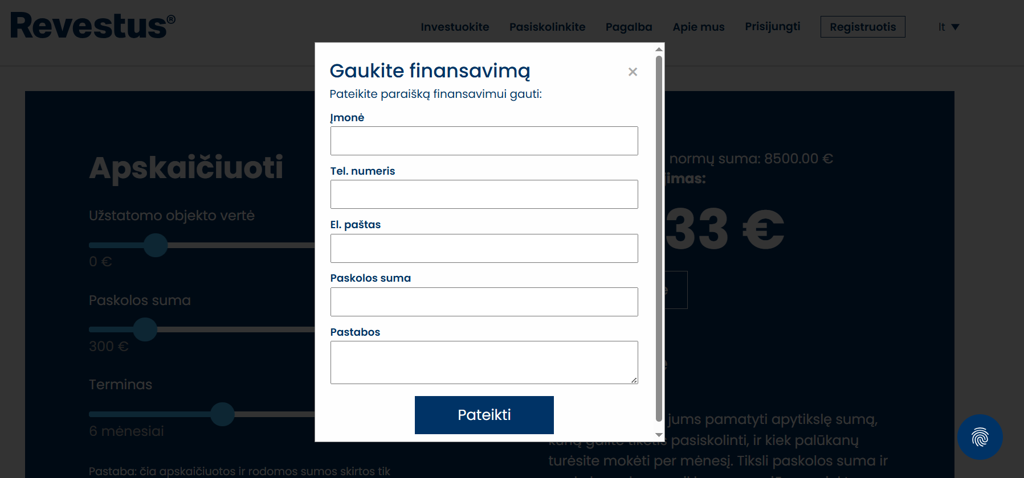This form sends out an email to info@revestus.lt by using our module Communication – Queries module. In a same fashion Contact form pop up is also set up in this module:
https://revestus-lt.creditonline.eu/admin.php?e=4&edit=111:Categories
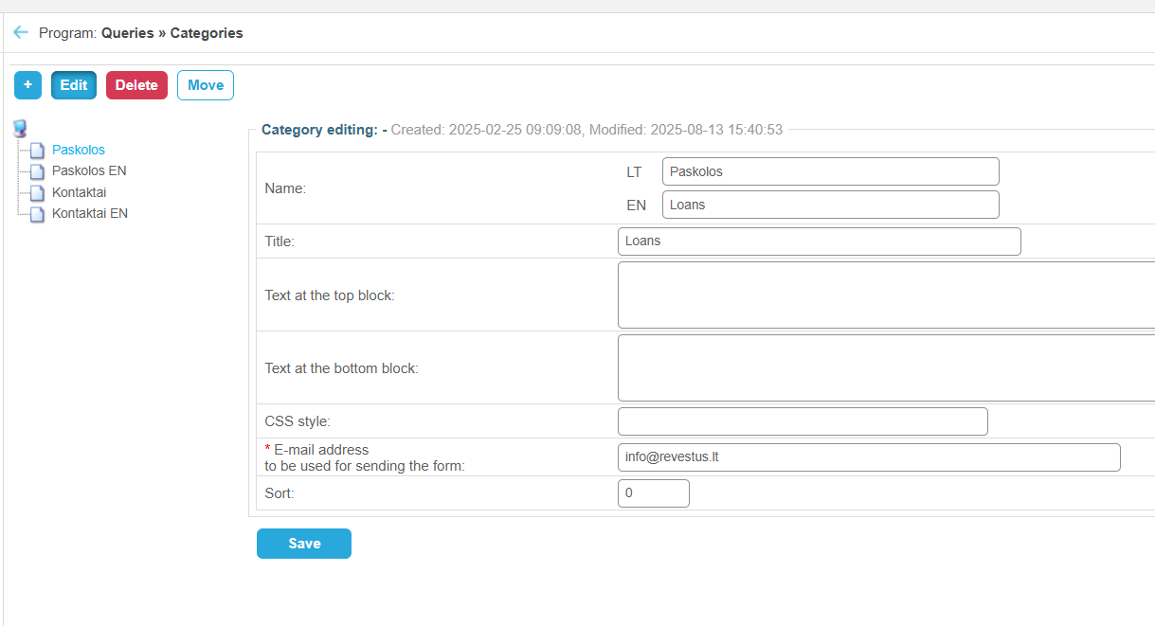
  - Borrowers that outside of the system get agreement with Revestus and are approved to publish their crowd funding project on a platform get added to the system manually by administrators.
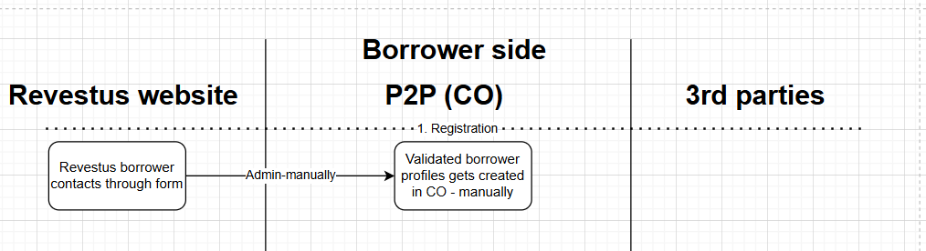
  - For adding project owner profile the field form ID1 is being used. The set of fields that need to be provided is following:
https://revestus-lt.creditonline.eu/admin.php?e=4&edit=45:admin-instances
Field type | Field name | Label
text | company_name | Name of legal entity
text | company_code | Legal entity code
text | tax_residency | State of residence for tax purposes
text | country | Country (registration address)
text | city | City (registration address)
text | street | Street (registration address)
text | house | House / Apartment number (registration address)
text | zipcode | Postal code
text | ceo_realname | Name of the company director
text | ceo_surname | Company director's name
email | email | Email
mob-phone | mob_phone | Phone number
  - This is being done through Client profile module: New – Project owner:
https://revestus-lt.creditonline.eu/admin.php?e=4&edit=10:customers
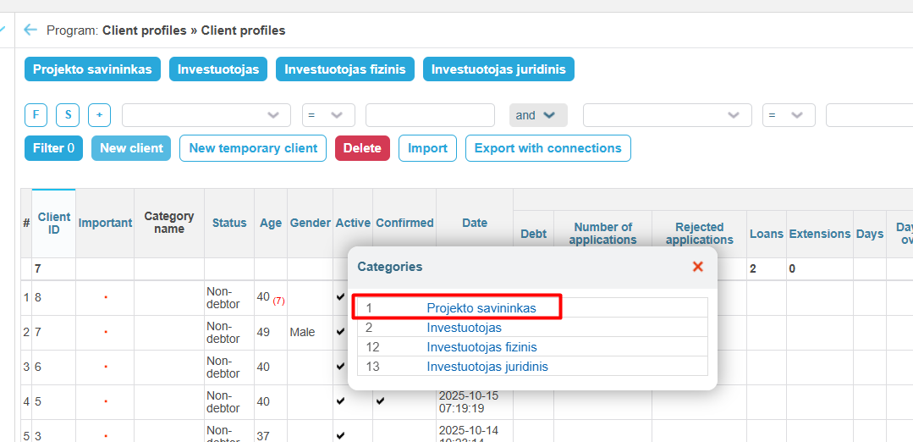
  - After adding the project owner details, first thing that needs to be done, is to connect Paysera wallet to project owners profile:
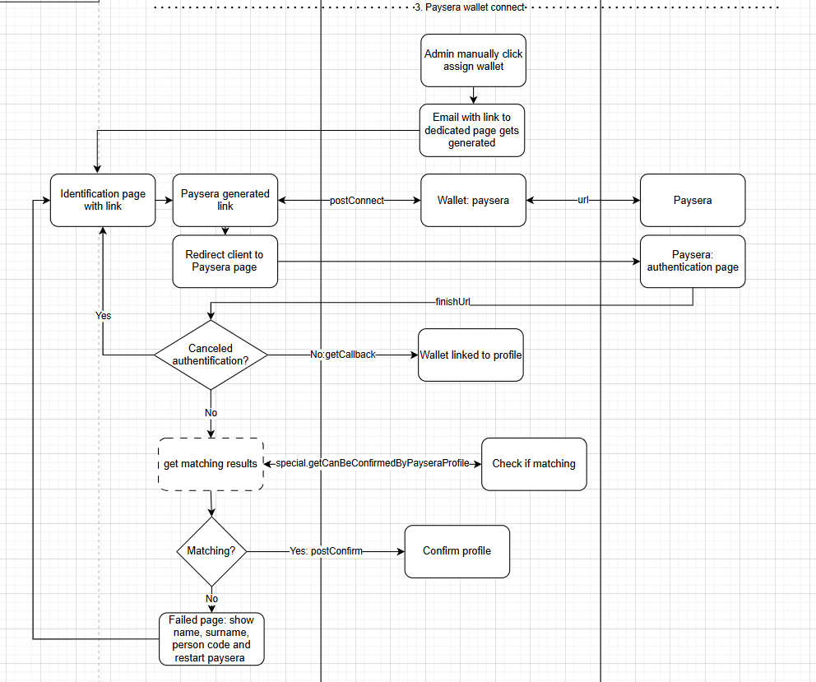
  - Inside the system that looks like a button in client profiles:
https://revestus-lt.creditonline.eu/admin.php?e=4&edit=10:customers&form_id=0&page=1&nid=1
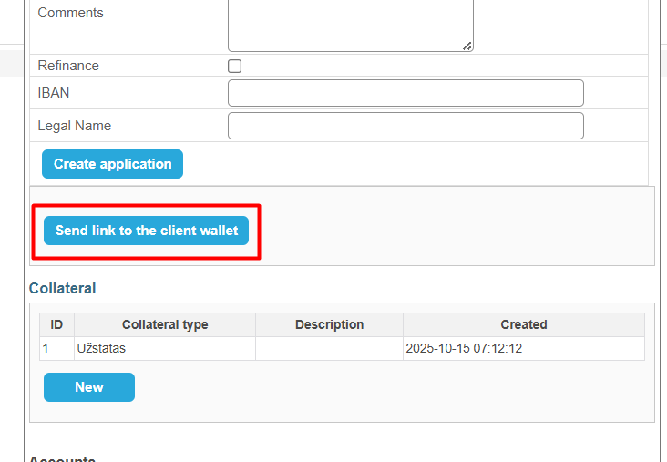
This button triggers one Communication template: customerWalletLink, the first link that is generated in a format: https://revestus.lt/recipient/authentification/%{uin}%. First template of this message type has a filter that sends it only to unconfirmed clients.
https://revestus-lt.creditonline.eu/admin.php?e=4&edit=15:messages-templates&nid=3
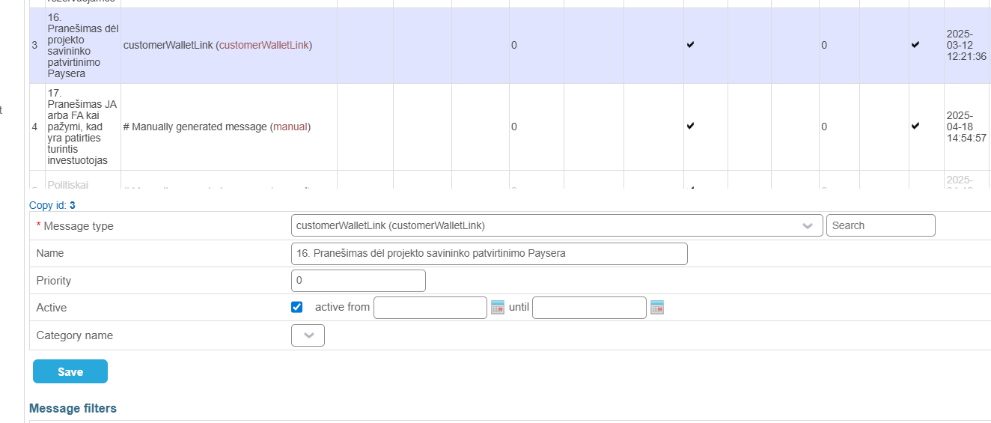
This link automatically redirects client to Paysera page for granting permission for Revestus platform to see his account balance and his personal details.
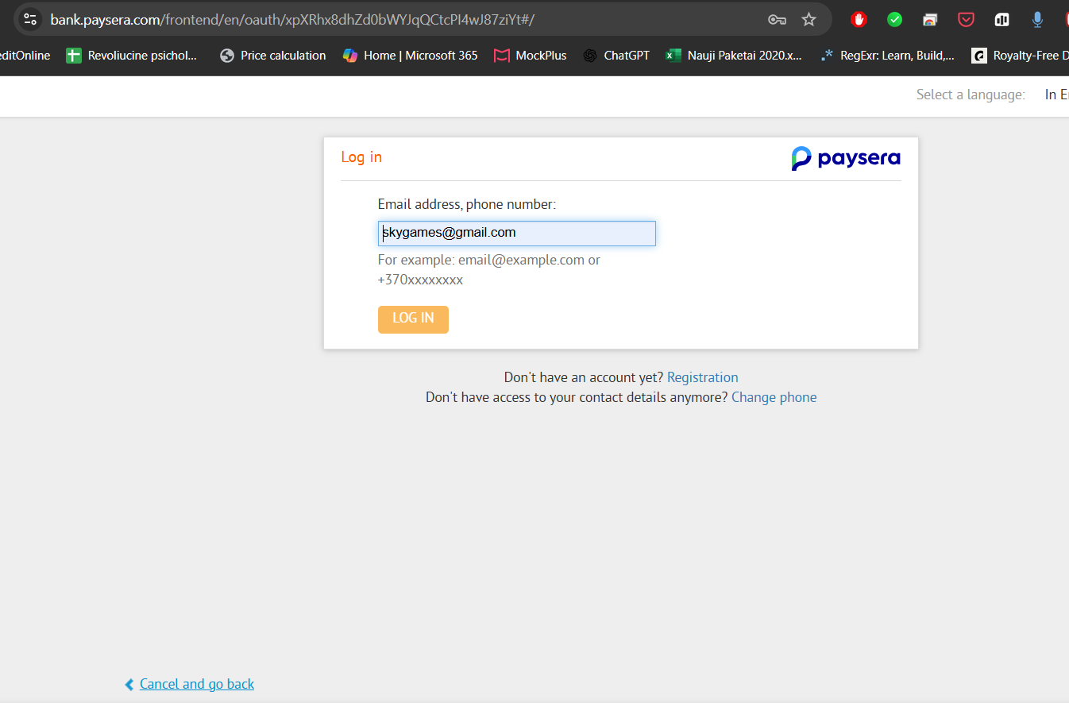
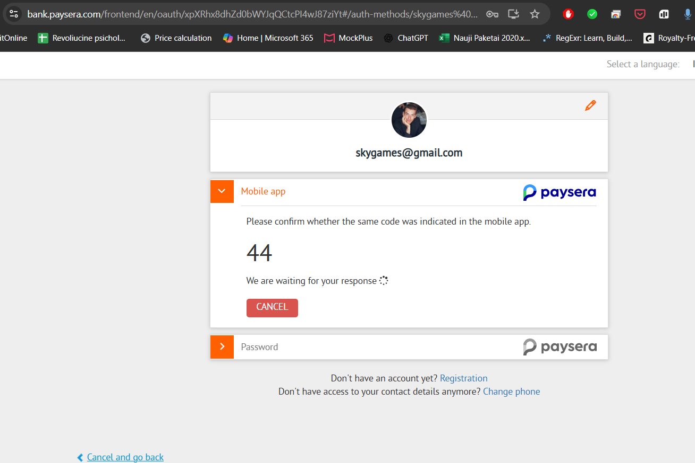
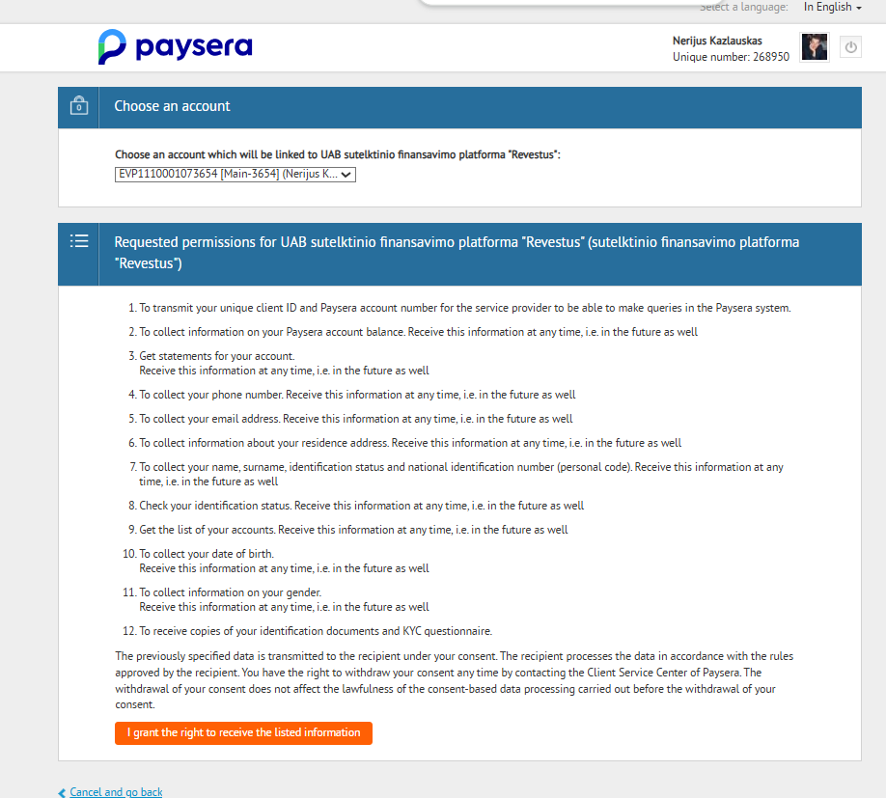
  - There is a custom development done, to create an extra API function for a front-end to check if wallet that has been connected and CreditOnline profile details match. It looks at person_code, realname and surname. The endpoint special.getCanBeConfirmedByPayseraProfile returns results to front-end whenever the profile can be confirmed or there is some sort of mismatch of details. Front-end uses postConfirm endpoint to confirm client profiles in case of match.
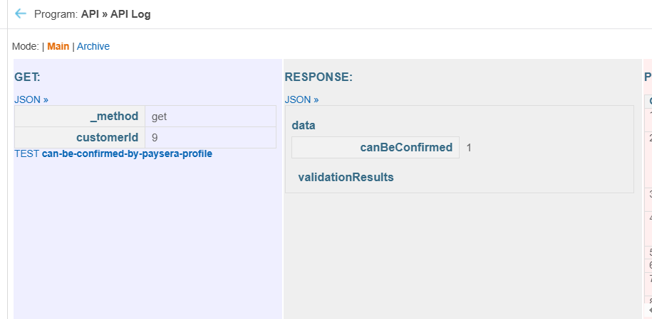
In case of mismatch client is shown details and possibility to restart profile connection process. 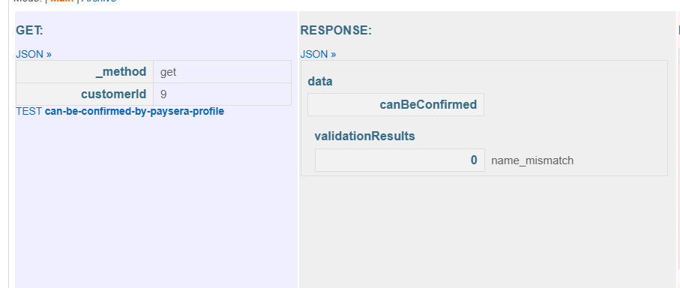
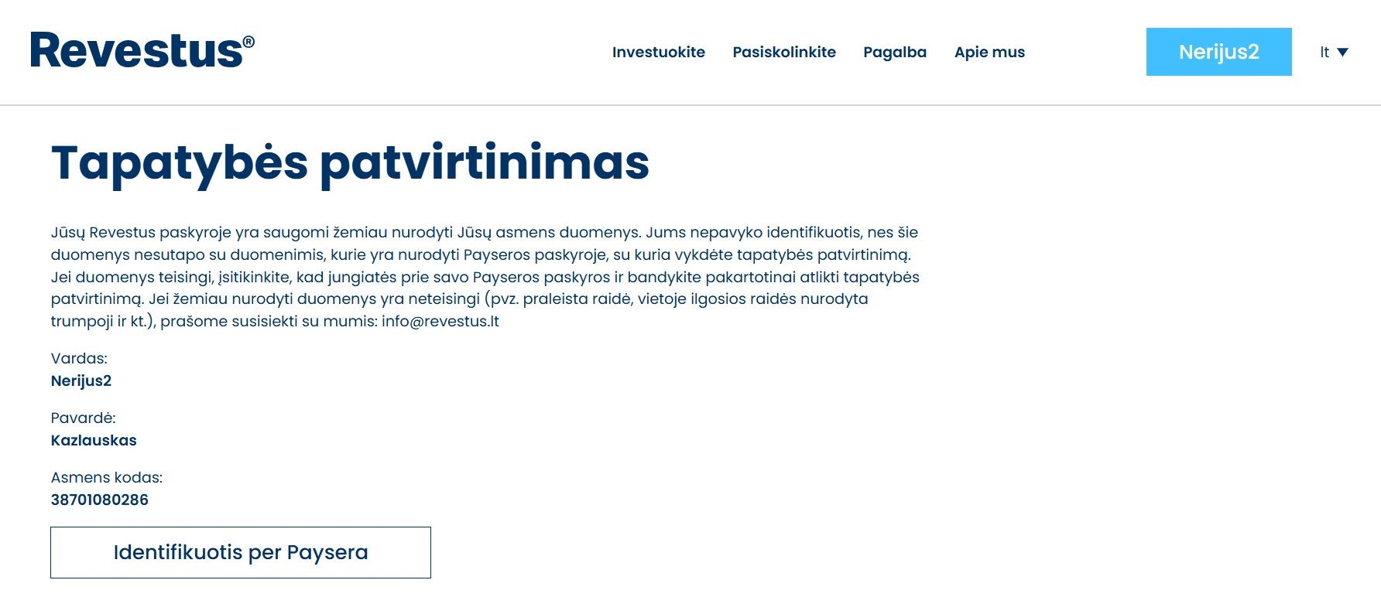
  - Once profile is connected to Paysera and confirmed, same button is used to send out another communication template of a same type, but with filter only for confirmed client profiles.
https://revestus-lt.creditonline.eu/admin.php?e=4&edit=15:messages-templates&nid=7
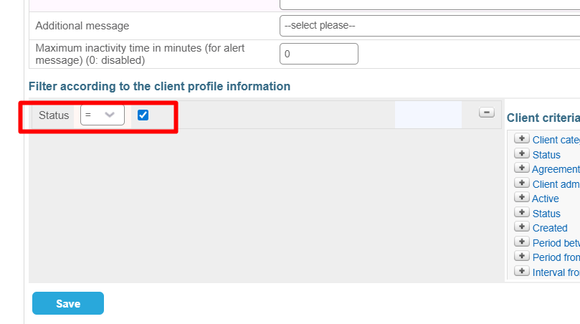
This message has a link in a format: https://revestus.lt/recipient/allowance/%{uin}%/2000000 that is used to ask project owners for allowance (permission revestus to manage a certain amount of money). 2 million indicates the full amount that is allowed to take from account, while there is a limit of one transaction amount that is being managed and set by Paysera. Currently as the plan is set to have 8 million amount permission and 4 million one transaction limits. The link also redirect client to Paysera, to login, but confirmation window is different:
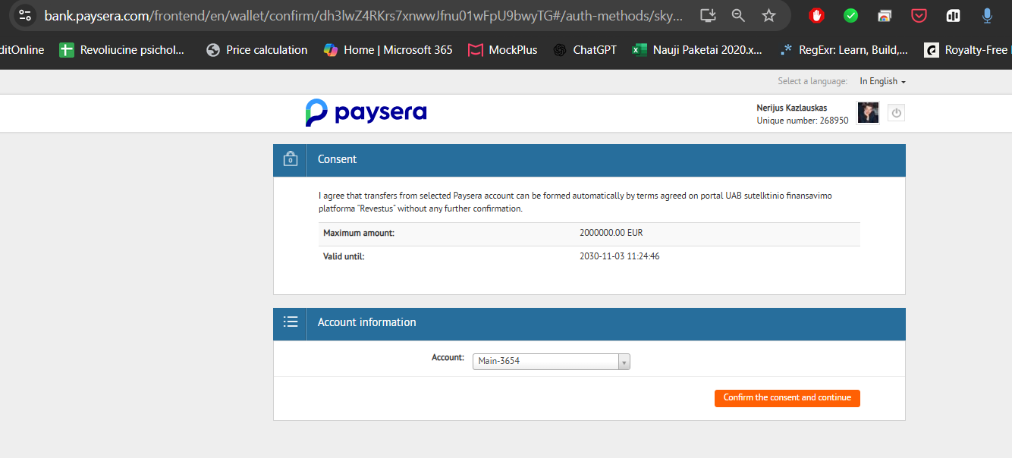
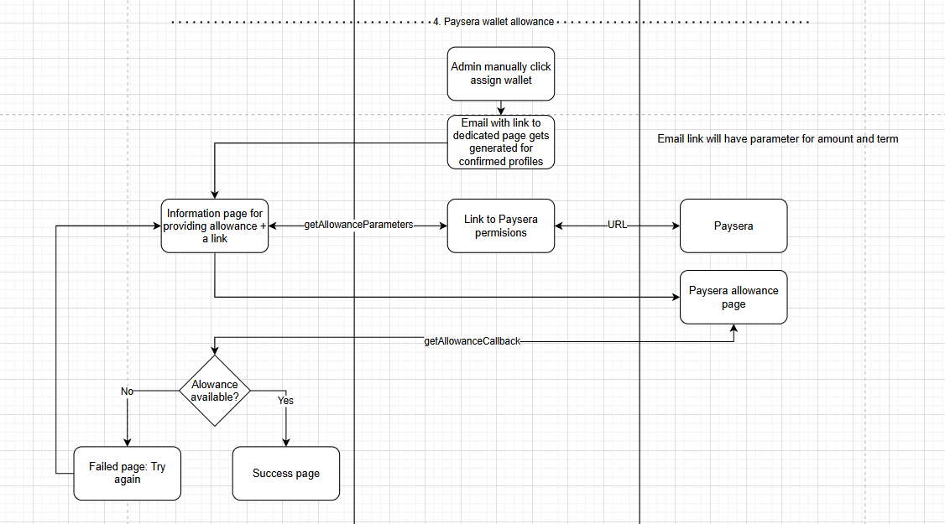
  - CreditOnline has a hardcoded limit on all allowances (investor or project owner) duration, which is set to 5 years. To change that, it has to be done by Developer as custom development.
  - Collateral can be added to borrower profile, that later on it’s ID will be used to pull information for Project description page on front-end. The form fields set for collaterals currently is:
https://revestus-lt.creditonline.eu/admin.php?e=4&edit=1206:deposit_fields
Field type | Field name
text | collateral_type
text | collateral_address
text | collateral_unique_number
text | collateral_area
text | collateral_value
text | collateral_evaluator
date | collateral_evaluation_date
text | collateral_owner
text | collateral_owner_id
text | collateral_owner_address
mob-phone | collateral_owner_phone
email | collateral_owner_email
file | collateral_ntr_report
file | collateral_evaluation_report
file | collateral_plan
text | project_id
- Project onboarding process
  - Next steps require administrators to create a loan application for the borrower:
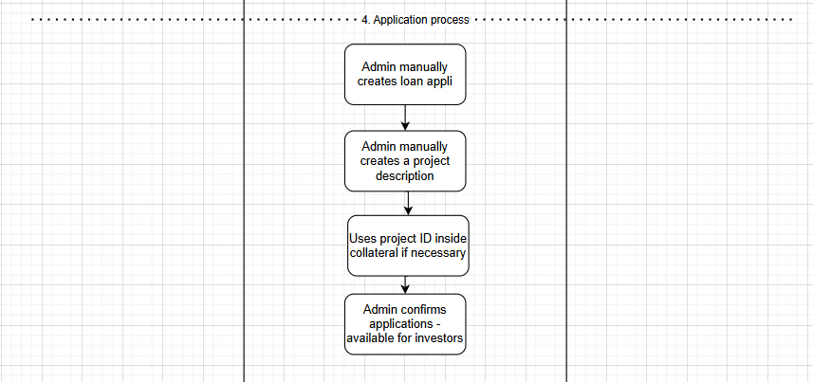 https://revestus-lt.creditonline.eu/admin.php?e=4&edit=10:customers&form_id=1&page=1&nid=2
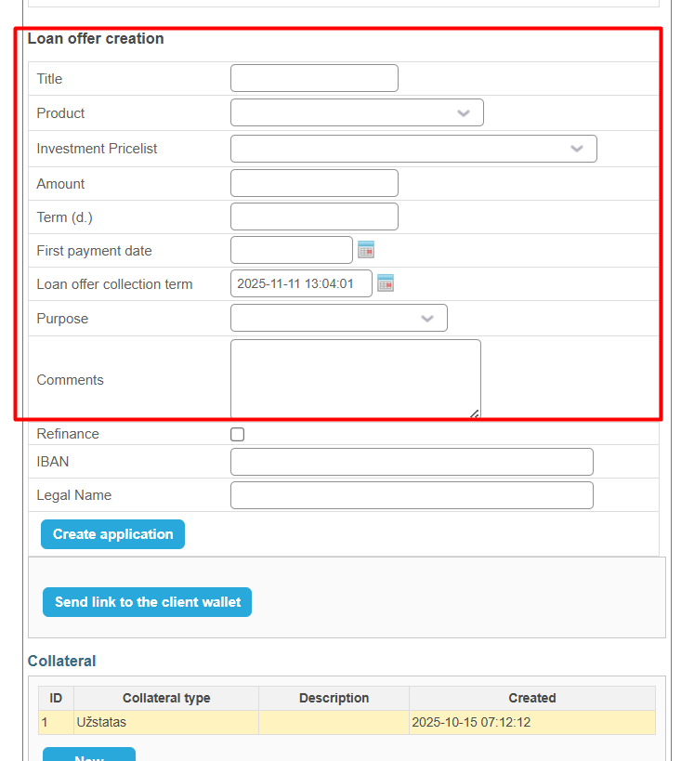
  - The creation of loan application involves few important consideration:
    - Title of project. This not will be visible on front-end, but will be used for internal recognition.
    - Product: basically controls the repayment schedule periods: monthly or quarterly. All products use bullet type of schedules.
    - Investment pricelist: controls the different ties of investments:
https://revestus-lt.creditonline.eu/admin.php?e=4&edit=700:price-list
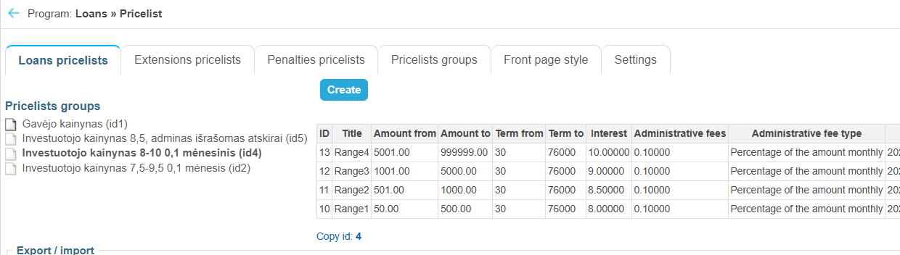
From this pricelist comes the minimal and maximum amounts of possible investments for the investor, it also defines based on investment what interest rate the investor will receive and what administrative fees will be available for the platform. Borrower pricelist basically does nothing. ID1
    - First payment date: ensure two things, then the first installment starts and on what day of a month a payment falls. Naturally Revestus must ensure that first payment date is far enough from Loan offer collection term.
    - Loan offer collection term: Comes with a default value of current date + 19days:
https://revestus-lt.creditonline.eu/admin.php?e=4&edit=800:config&group=config_loanoffers
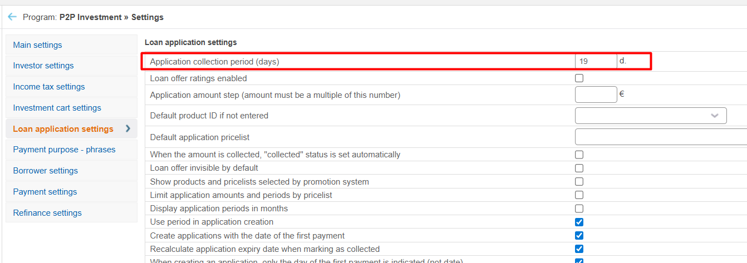
    - Purpose: is a mandatory fied and its options are predefined in Application purposes submodule.
    - Refinance section with IBAN and Legal name are used only in case of refinancing project. Where the process stays all the same but, the collected funds will be transferred to provided IBAN if Refinance checkbox is marked. This can be added later on already created loan application:
https://revestus-lt.creditonline.eu/admin.php?e=4&edit=800:investment_admin_loan_offers&page=1&nid=4
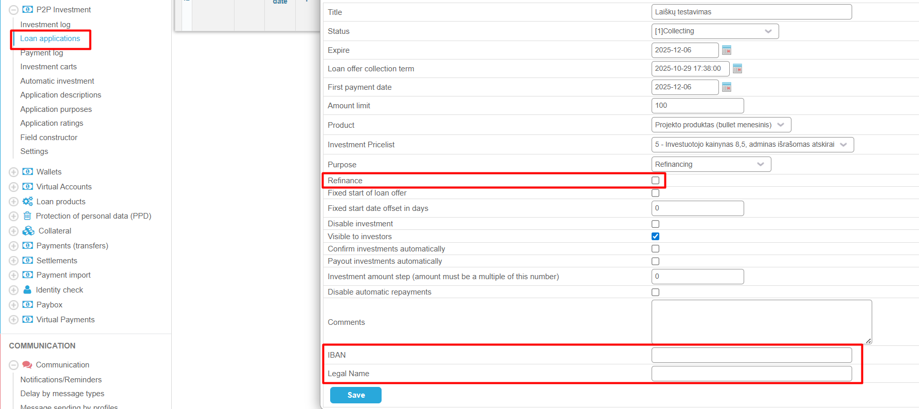
  - Once application is available, project description entry appears requiring to fill in: Loan container fields constructor a form ID1 that has following fields:
https://revestus-lt.creditonline.eu/admin.php?e=4&edit=603:LoansContainersFieldsFormsInstances
Field type | Field name
file | main_image_url
multiupload | images
text | project_name
text | address
textarea | short_description
select | risk_level
select | project_rating
text | project_purpose
text | ltv
text | ltv_max
text | primary_mortgage
text | company_name
file | owner_image_url
text | owner_address
text | owner_phone
text | owner_website
text | owner_company_code
multiupload | documents
multiupload | owner_documents
textarea | additional_risks
text | coordinates
text | payment_of_interest
textarea | owner_description
date | launch_date
text | owner_name
text | owner_title
text | main_image_url_name
textarea | description
submit | save
checkbox | show_news
textarea | news
  - After filling in and adding project ID to collateral administrator can present the project to investors on front-end by confirming loan application in control center.
- Project funding and repayment
  - Investors use front-end to invest into project, once the collection of funds finish, administrator will see loan application in control center with possibility to Mark as Financed.
  - After clicking Mark as Financed system starts a payout process:

  - Payout process can differ depending if there was a refinance option selected:
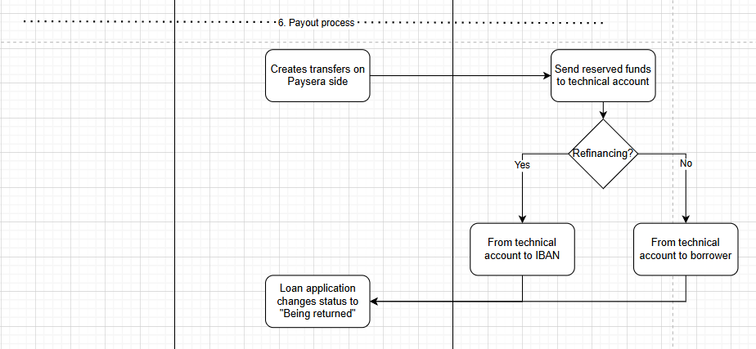
  - Once loan application goes into status being returned, cron timer:
https://revestus-lt.creditonline.eu/admin.php?e=4&edit=16:scheduler&nid=3 \modules\investment\Controllers\InvestmentPaymentEventsController::processReturns checks every days if installment date has come in order to take funds from a project owner account:
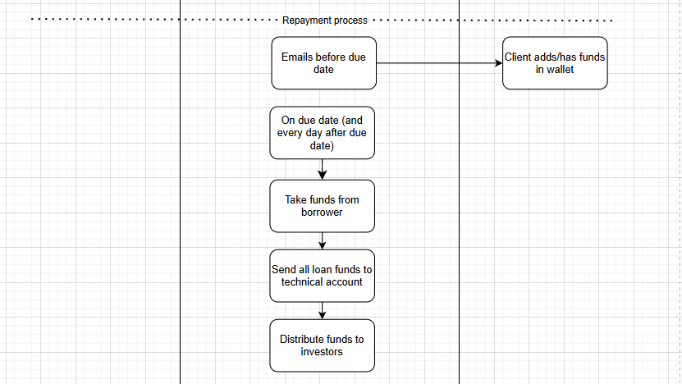

- Investor process
- Registration:
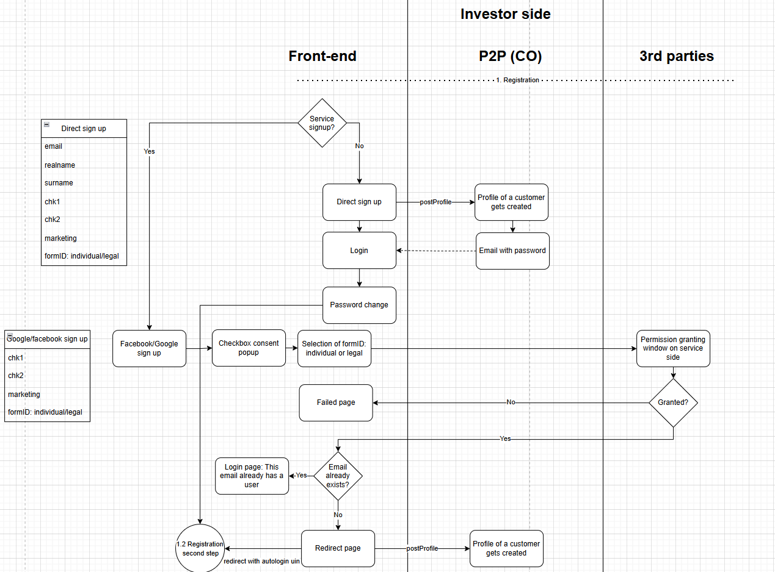
  - Revestus has two registration options: 1st direct registration and 2nd Google/Facebook service signup
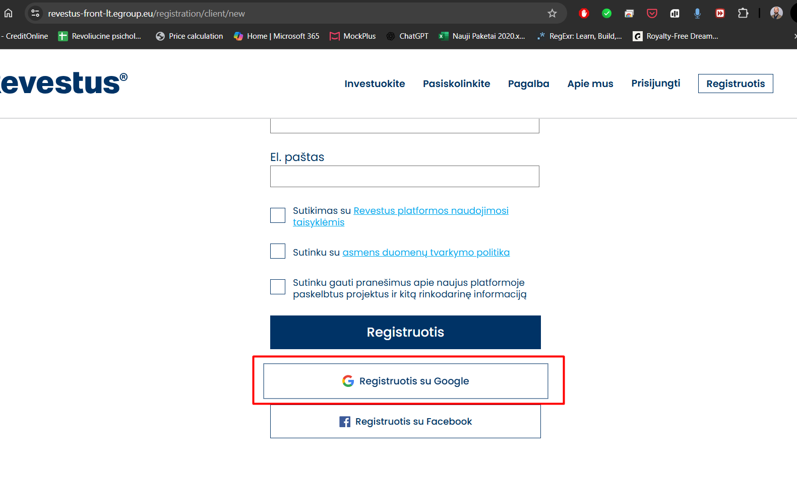
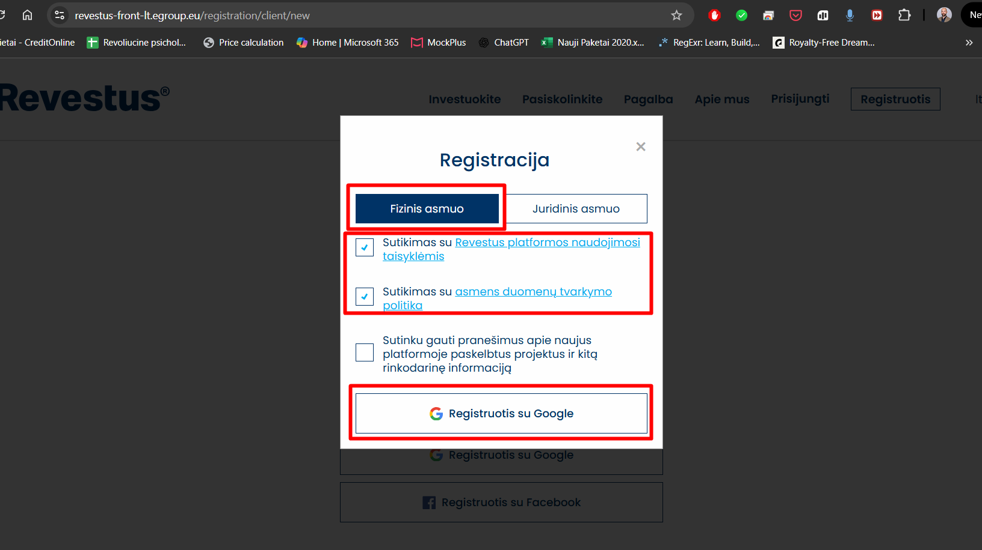
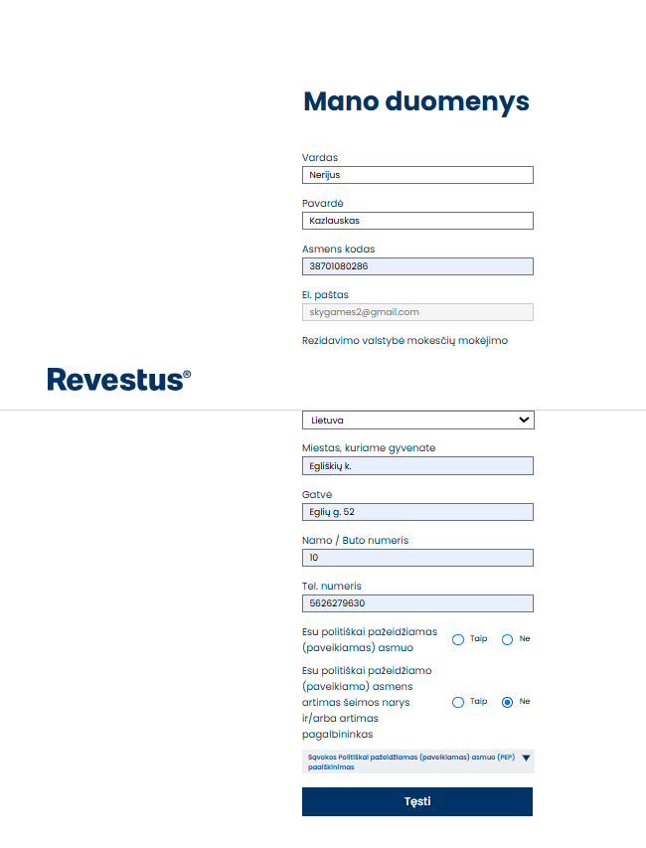
  - Direct registration require to provide only few fields: email, realname, surname, chk1, chk2, marketing and selected form decides if it is individual investor or legal: formID12 for Individual https://revestus-lt.creditonline.eu/admin.php?e=4&edit=45:admin-instances&cid=12
and form ID13 for legal investor. https://revestus-lt.creditonline.eu/admin.php?e=4&edit=45:admin-instances&cid=13
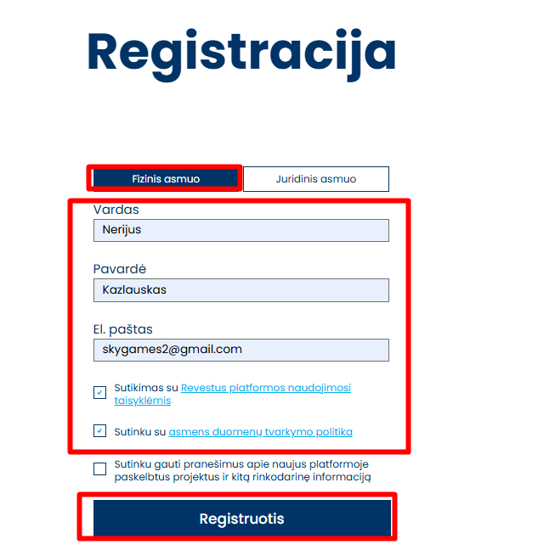
  - Service registration all the same except it requres to provide only chk1, chk2 and marketing fields and what form to use based on individual/legal investor. The rest of fields like email, realname, surname are taken from the service providers.
  - After first initial postProfile:
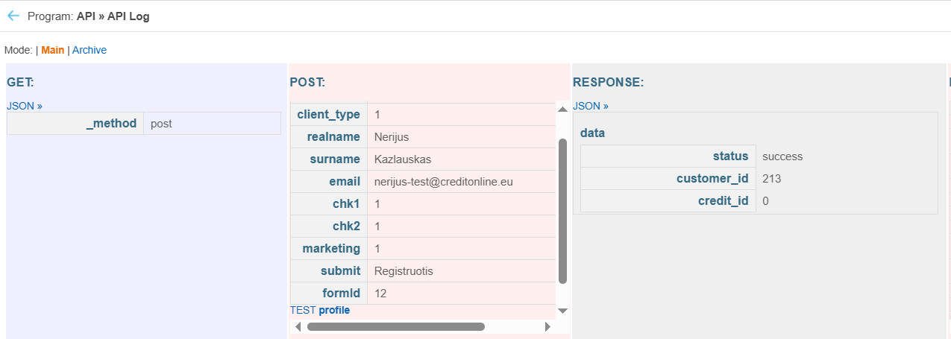
Over direct registration, client recieves and email with temp password and is required to login and change the password, before going to second registration step, while service registration automatilly logs in customer over uin and shows a second registration step.
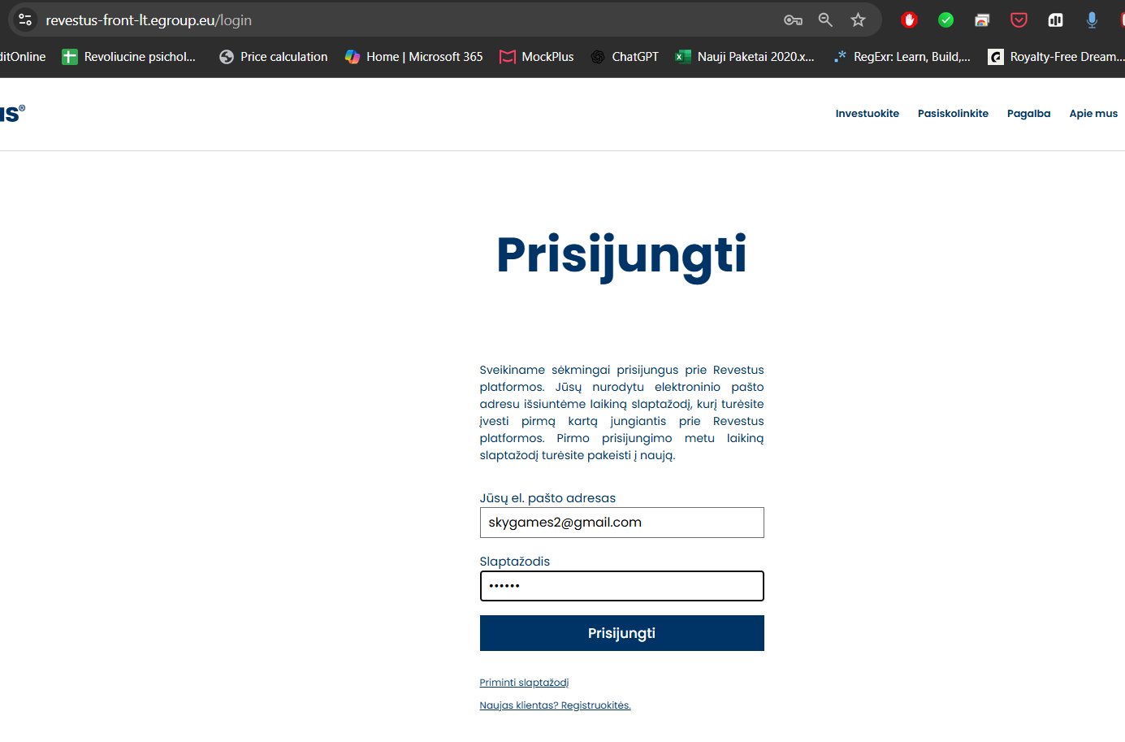
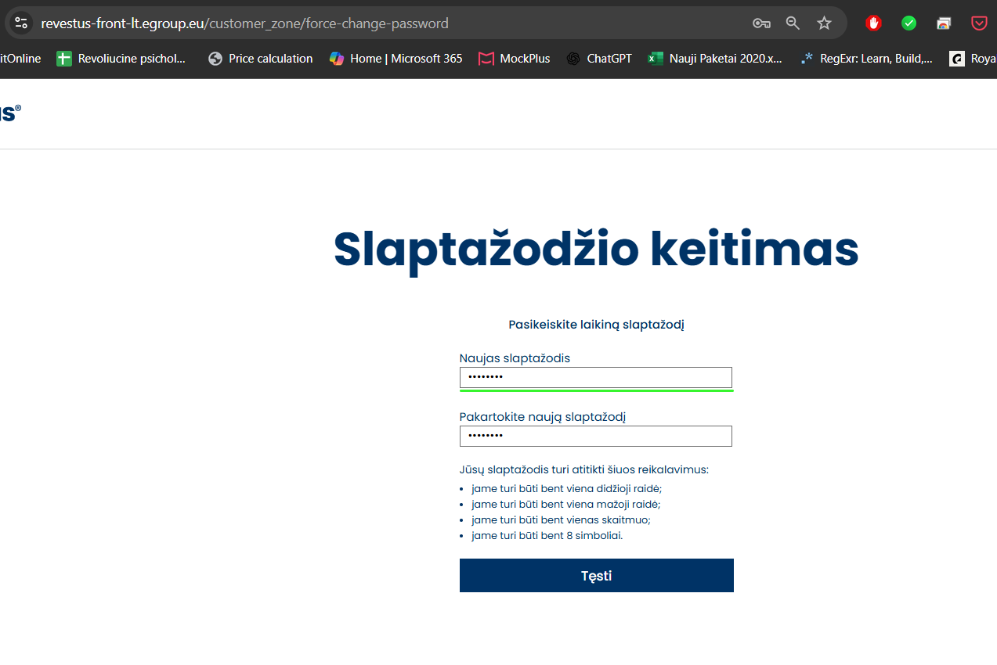
  - Second registration step, happens only after client manages to login, manually or automaticaly and needs to fill in more personal details fields on corresponding ID12/13 forms. Details get added using putProfile for ID4 for Individual investor:
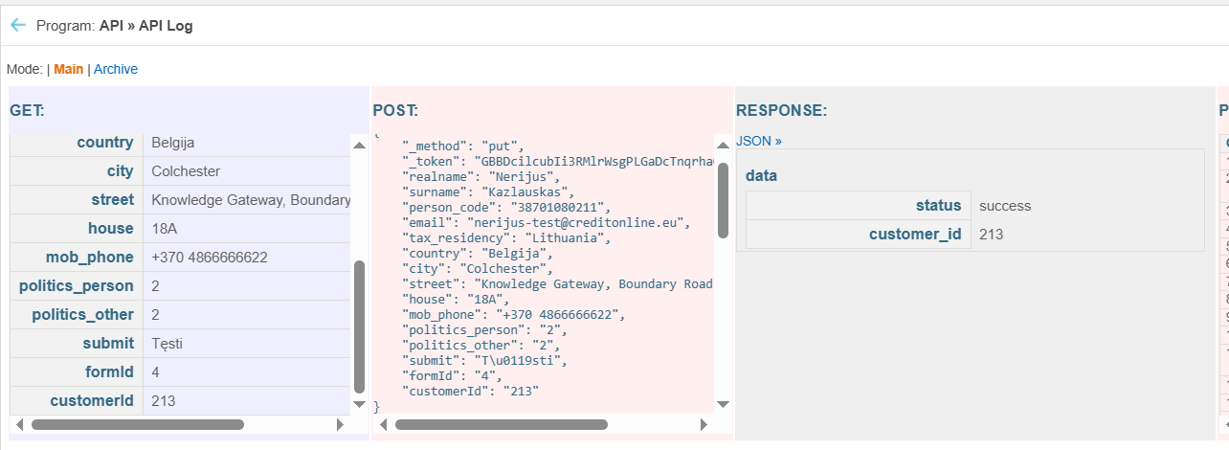 https://revestus-lt.creditonline.eu/admin.php?e=4&edit=45:admin-instances&cid=4
Field name | Label
realname | Name
surname | Surname
person_code | Personal code
tax_residency | State of residence for tax purposes
country | Country (registration address)
city | City (registration address)
street | Street (registration address)
house | House / Apartment number (registration address)
zipcode | Postal code
email | Email
mob_phone | Phone number
politics_person | I am a politically vulnerable person.
politics_other | I am a close family member and/or close assistant of a politically vulnerable (affected) person
politics_other_name | Identify the politically exposed person and their duties

  - For Legal investor, putProfile on formID14:
https://revestus-lt.creditonline.eu/admin.php?e=4&edit=45:admin-instances&cid=14
Field name | Label
realname | Name
surname | Surname
person_code | Personal code
tax_residency | State of residence for tax purposes
country | Country (registration address)
city | City (registration address)
street | Street (registration address)
house | House / Apartment number (registration address)
zipcode | Postal code
email | Email
mob_phone | Phone number
politics_person | I am a politically vulnerable person.
politics_other | I am a close family member and/or close assistant of a politically vulnerable (affected) person
politics_other_name | Identify the politically exposed person and their duties
  - Both indivudal and legal investors fill in the same third registration step with a formID10, using putProfile function:
https://revestus-lt.creditonline.eu/admin.php?e=4&edit=45:admin-instances&cid=10
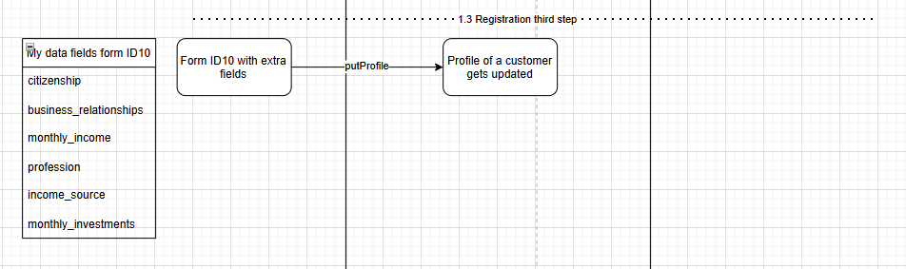
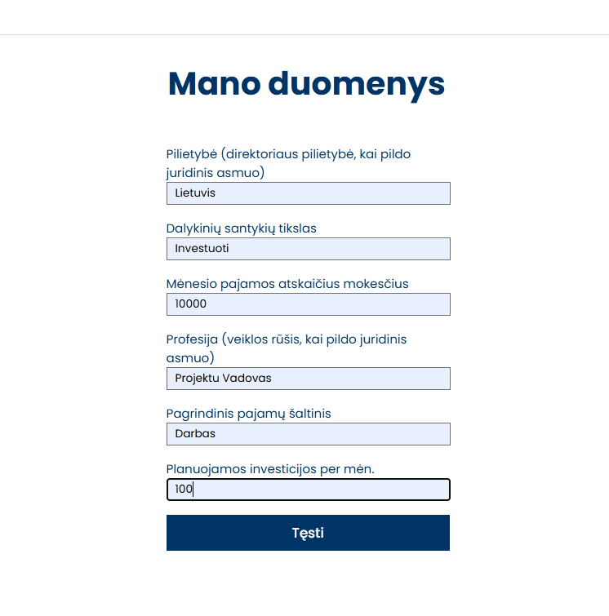 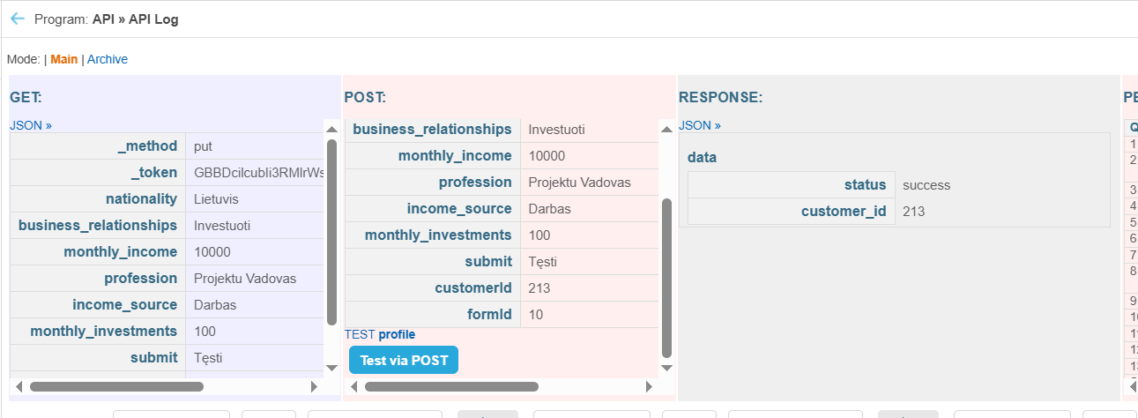
  - Fourth registration is step is same for individual and legal investor: Questioneer. It uses Solvency declaration log module:
https://revestus-lt.creditonline.eu/admin.php?e=4&edit=700:solvency-declarations
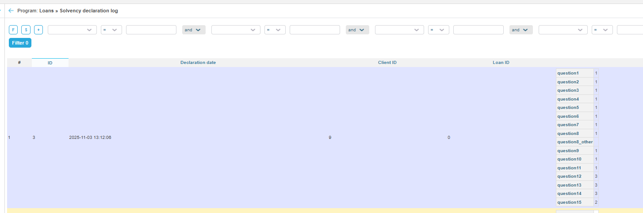
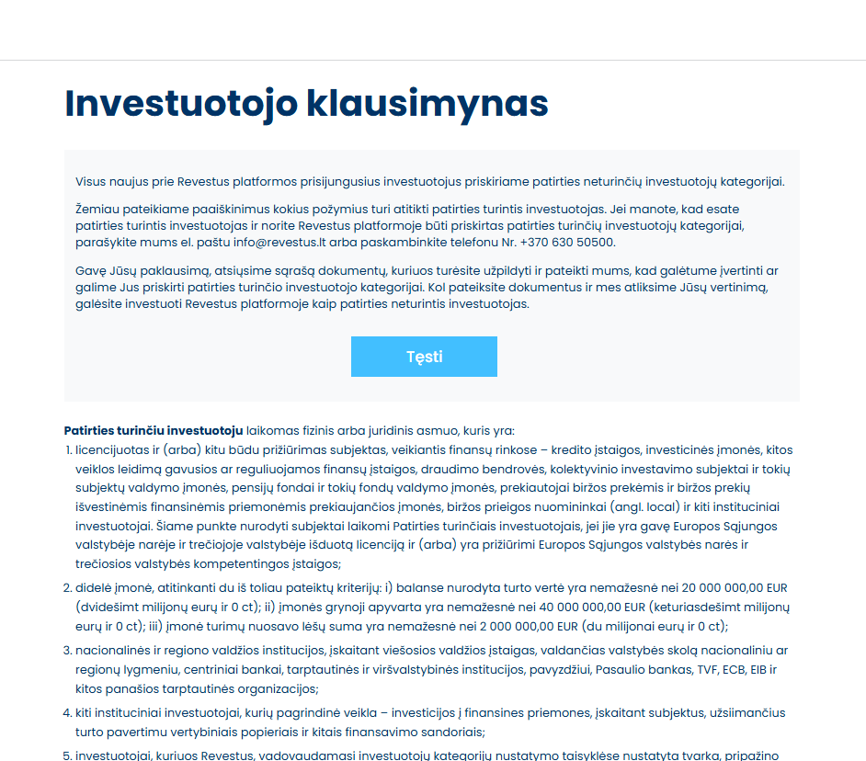
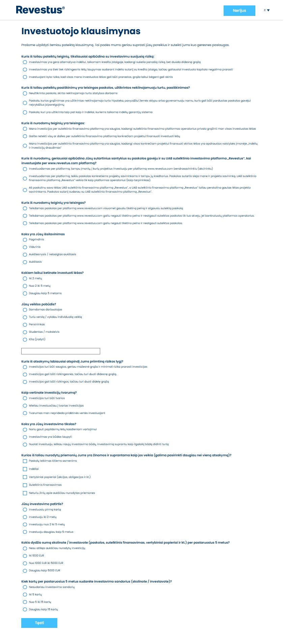
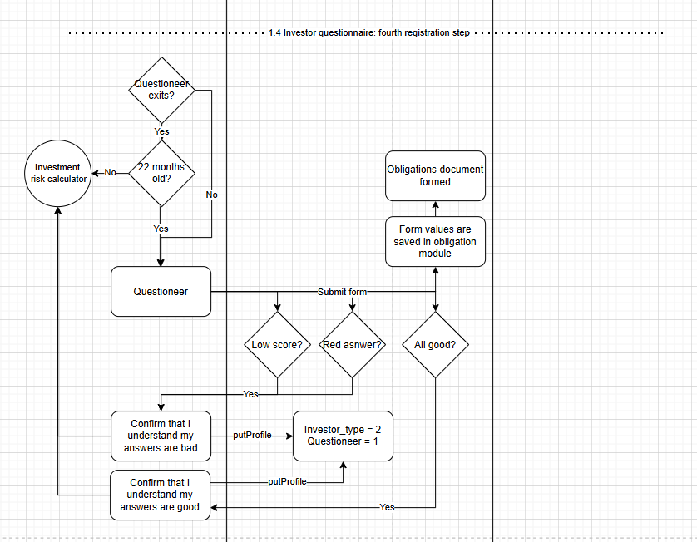
  - After filling in declartion, a document is also generated automatically with a type: Obligation form
https://revestus-lt.creditonline.eu/admin.php?e=4&edit=775:admin-documents-templates&nid=2
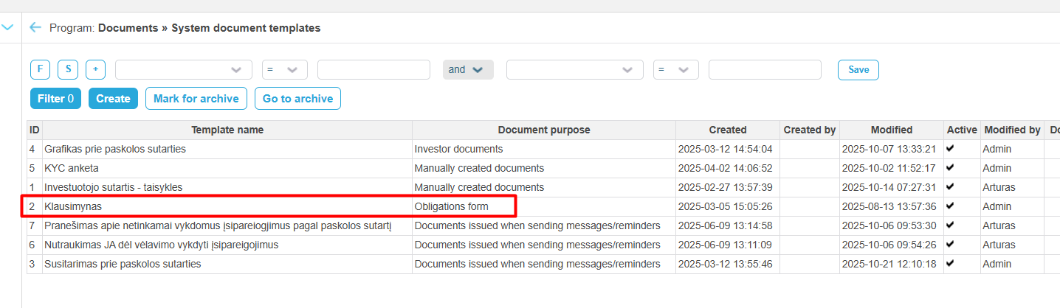
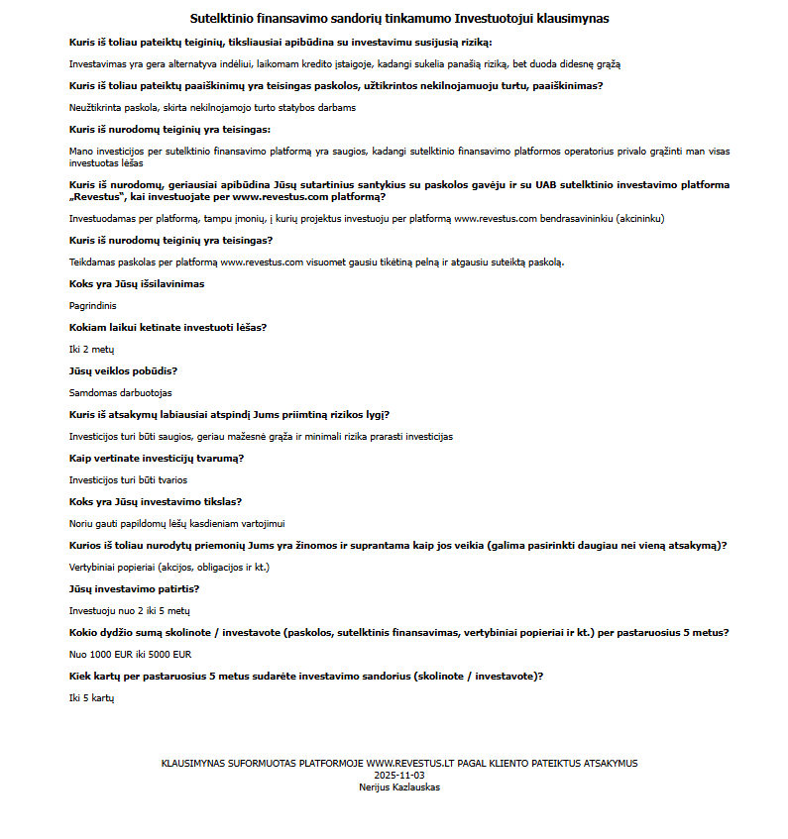
  - Questions content is hardcoded by Algis and if any change is needed is a custom work.
  - Questioneer has a logic of scoring points, if not enough points are scored next step shows a warning message:
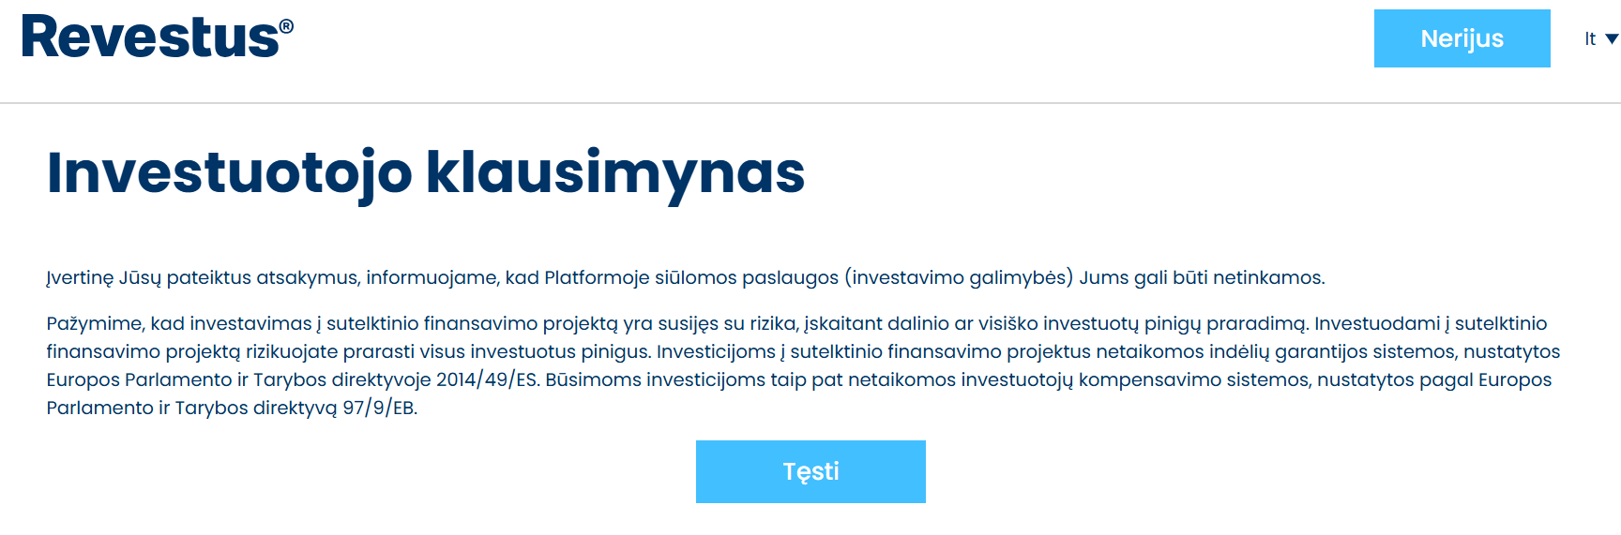
But it does not matter since client simply continues with his registration. If enough points scored the message it is more postive and customer still continues with registration.
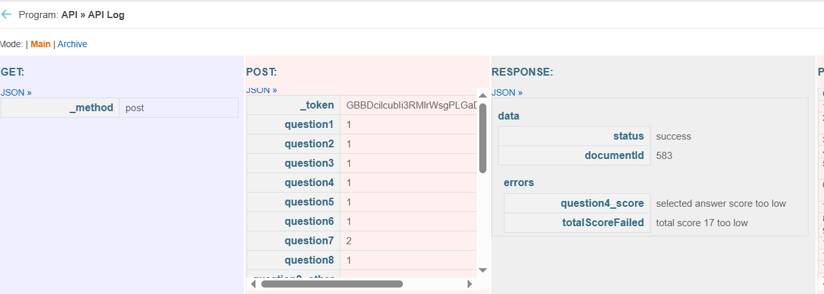
All customer start with investor_type 2, which is unprofesional investor.
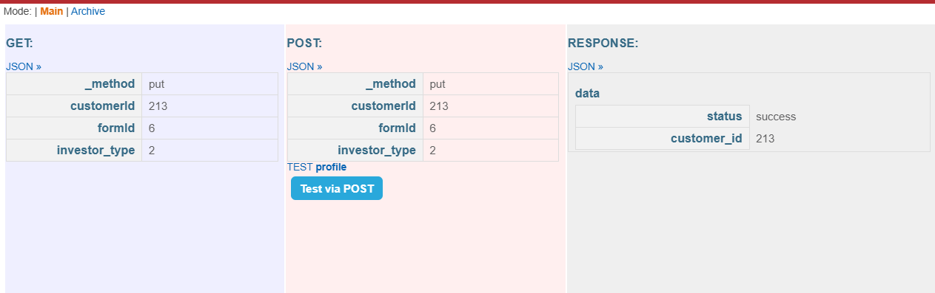
On a same step after questioneer we also flag with put profile that questioneer has been responded:
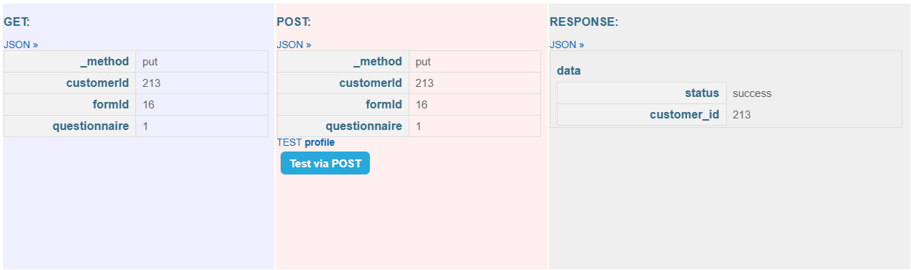
The document ID5 – KYC form also is generated:
https://revestus-lt.creditonline.eu/admin.php?e=4&edit=775:admin-documents-templates&nid=5
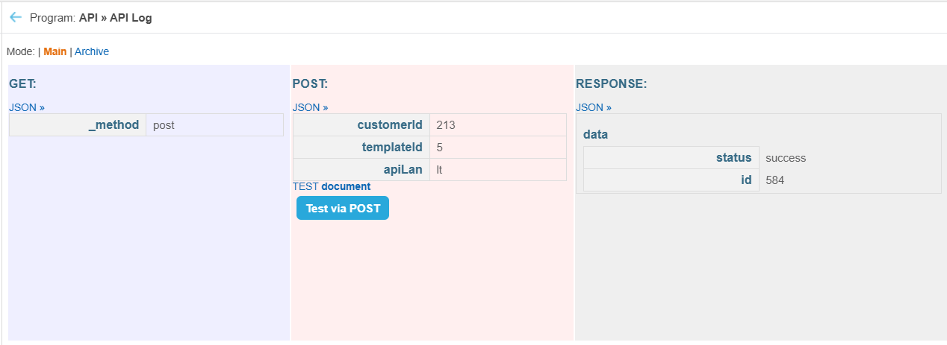
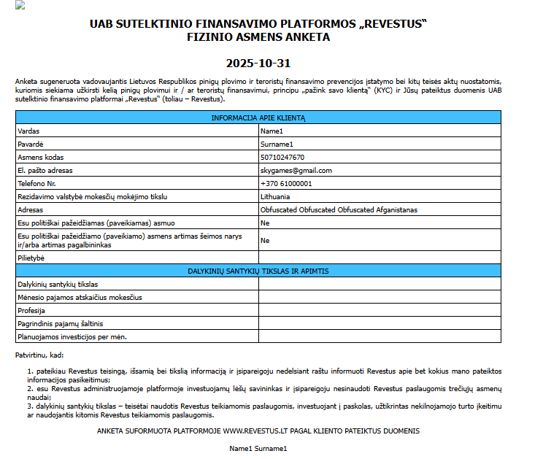
  - Firth registration step is Risk calculator that is filled in by individual and legal investors:
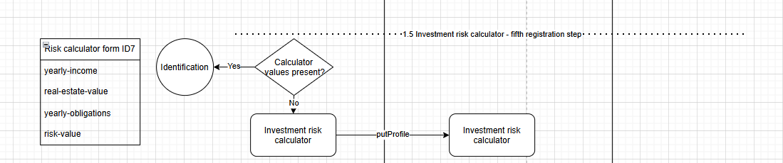
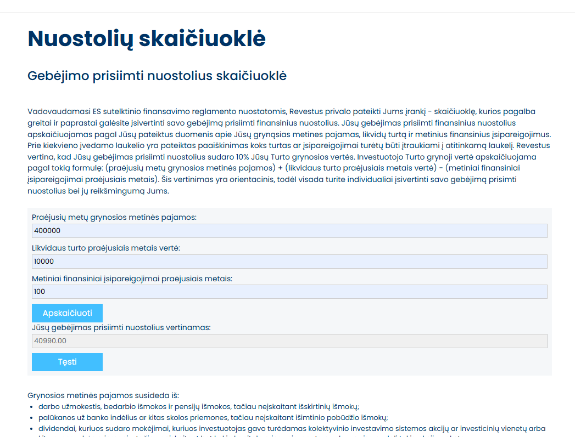
Client simply provides values, and front-end calculate risk values and saves everything to customer profile with putPorfile under form ID7:
https://revestus-lt.creditonline.eu/admin.php?e=4&edit=45:admin-instances&cid=7
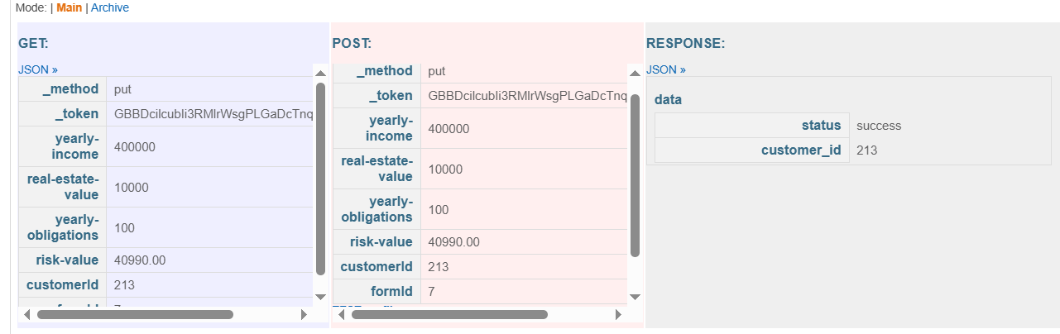
  - Sixth registration step: Identification. This is done by connecting to client‘s Paysera wallet and retrieving apart from wallet balance, name, surname and personal code.
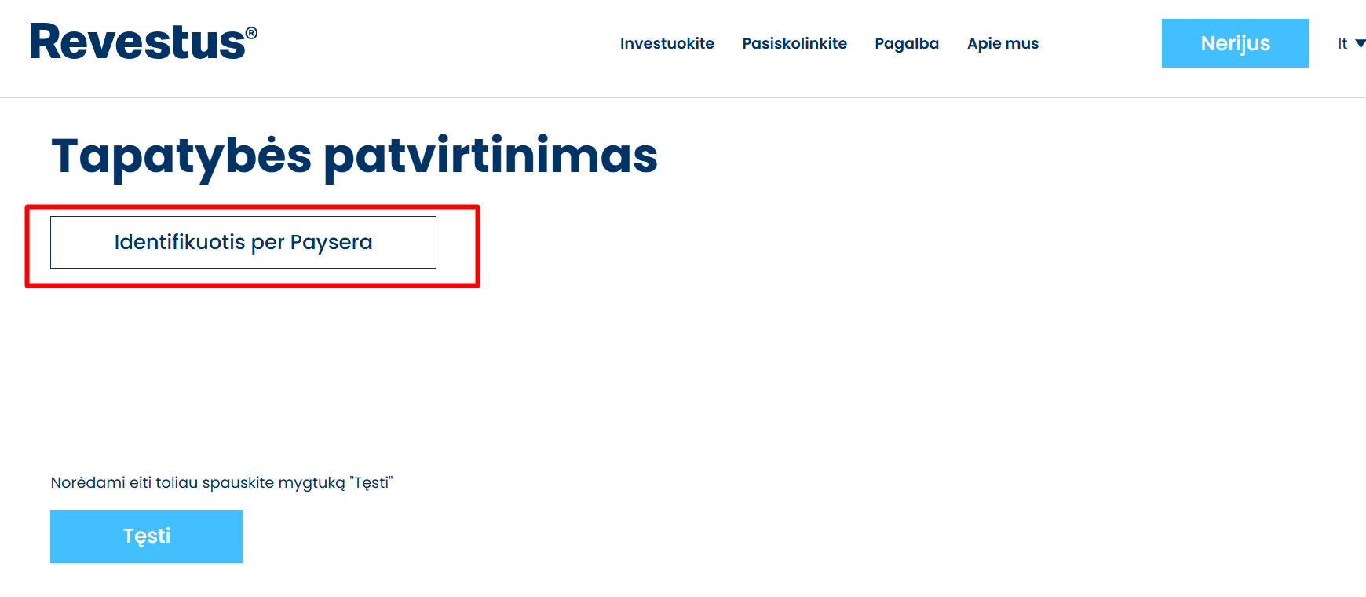
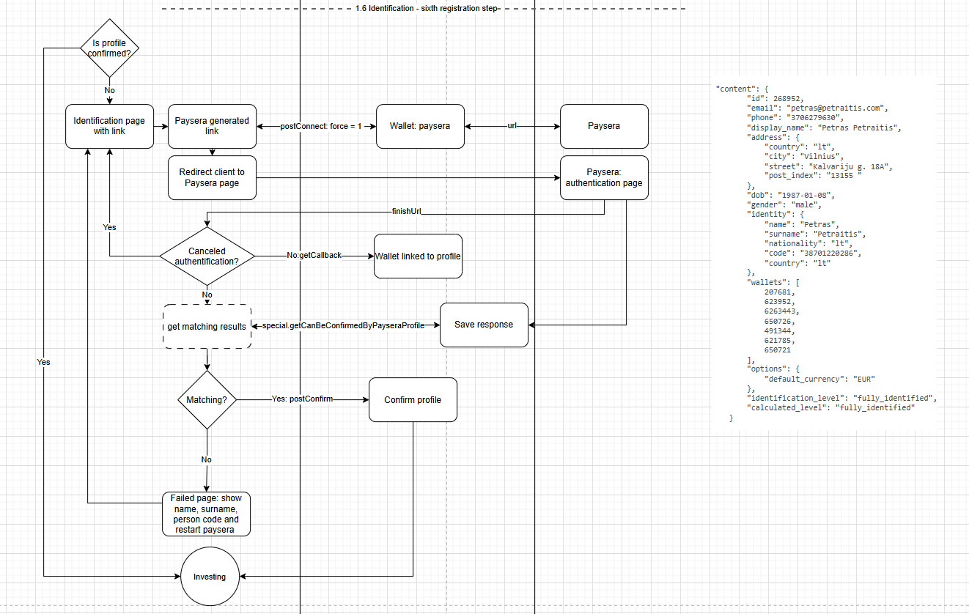
The if after checking connection to Paysera wallet the details match by using: special.getCanBeConfirmedByPayseraProfile custom API endpoint, front end uses postConfirm on a client profile, if it does not match for some reason, a page for failed match is shown with possibility for the investor to try paysera connection again.
- Investment: After registrations steps are complete customer can start investing.
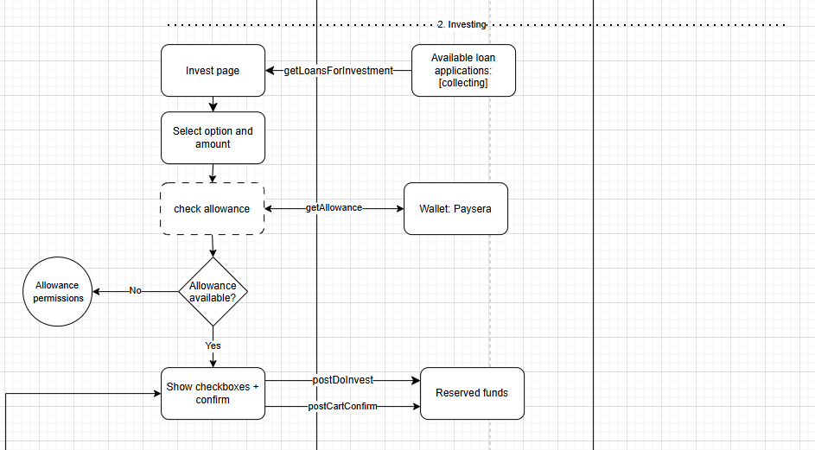
  - Investor selects first a project to invest and the amount:
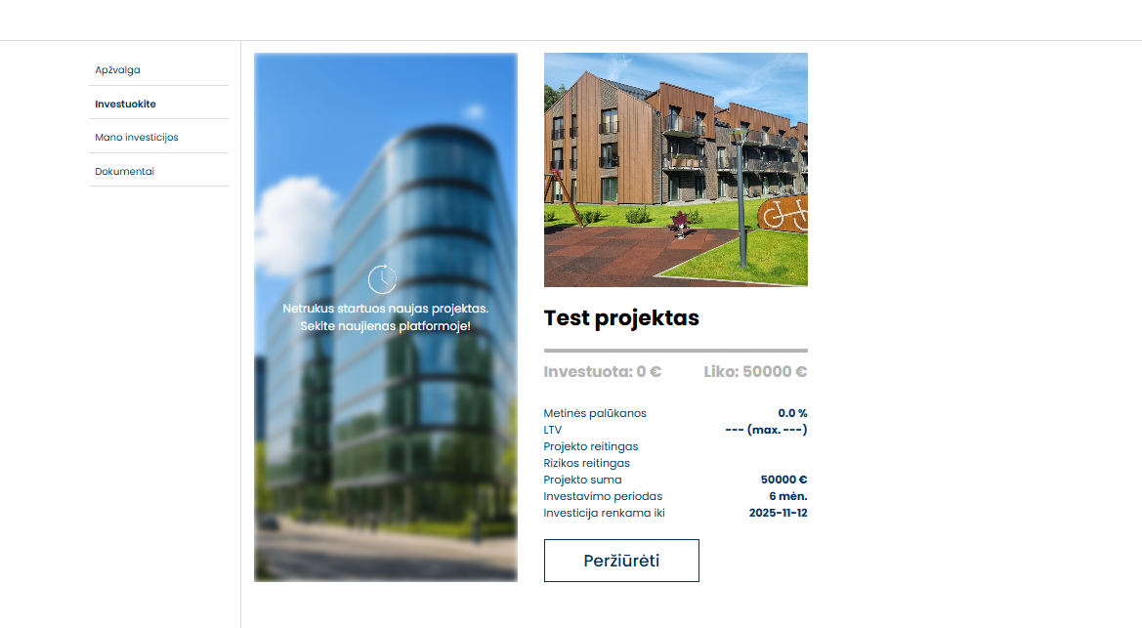
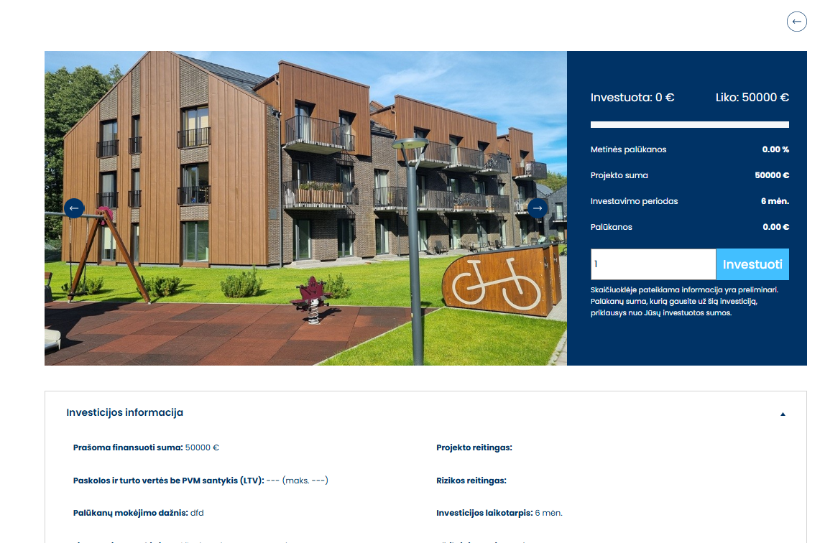
  - After that a few checkboxes are shown to consent with conditions:
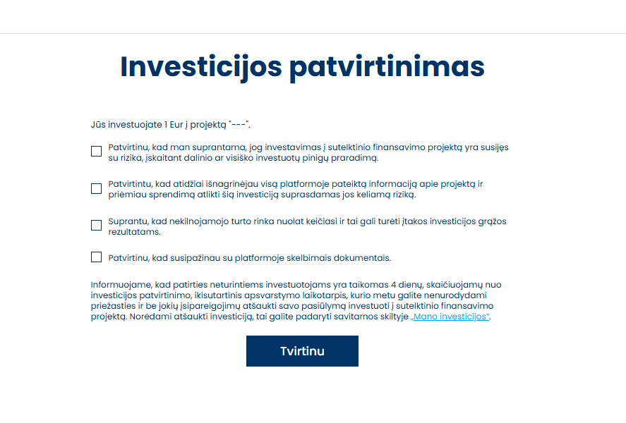
  - Investing process requires investor to give allowance permisions, this happens only if client does not have active allowance or the allowance has expired:
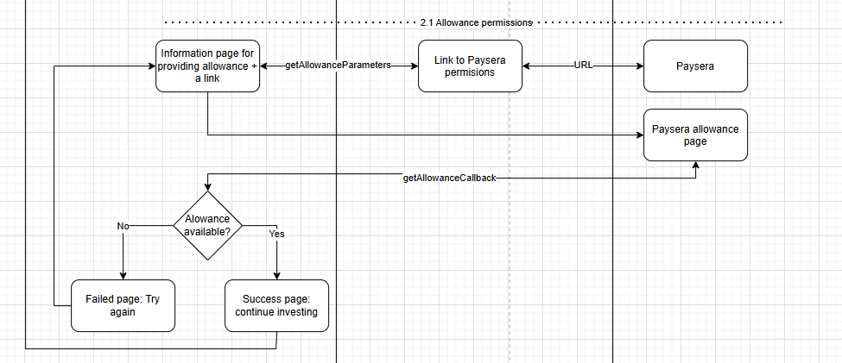
  - The allowance limits for amount is defined by front-end and currently set to 2 million. This can be change by Tomas Baltazaris as custom dev. While Allowance period will be the same as project owners, set by the back-end hardcoded value of 5 years. This can be changed by Vytautas as custom dev.

- Secondary processes and functionalities
  - Password change. This functionality is especially necessary for investors that went through Google/Facebook registration process and do not have old password. For that reason a functionality of remind my password function is being used with issuing of temporal password in client zone:
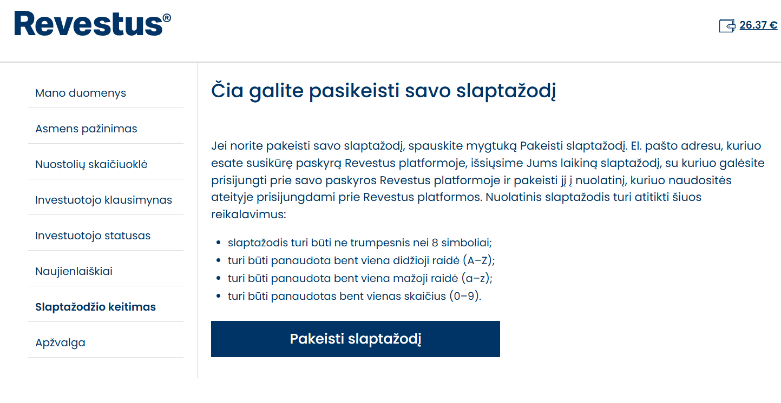
  - Cool down process. By the setting is set to 4 days:
https://revestus-lt.egroup.eu//admin.php?e=4&edit=800:config&group=config_loanoffers
    - The process and logic of cool down is divided the information on back-end and actions on front-end to hide projects that enter a cool down process:
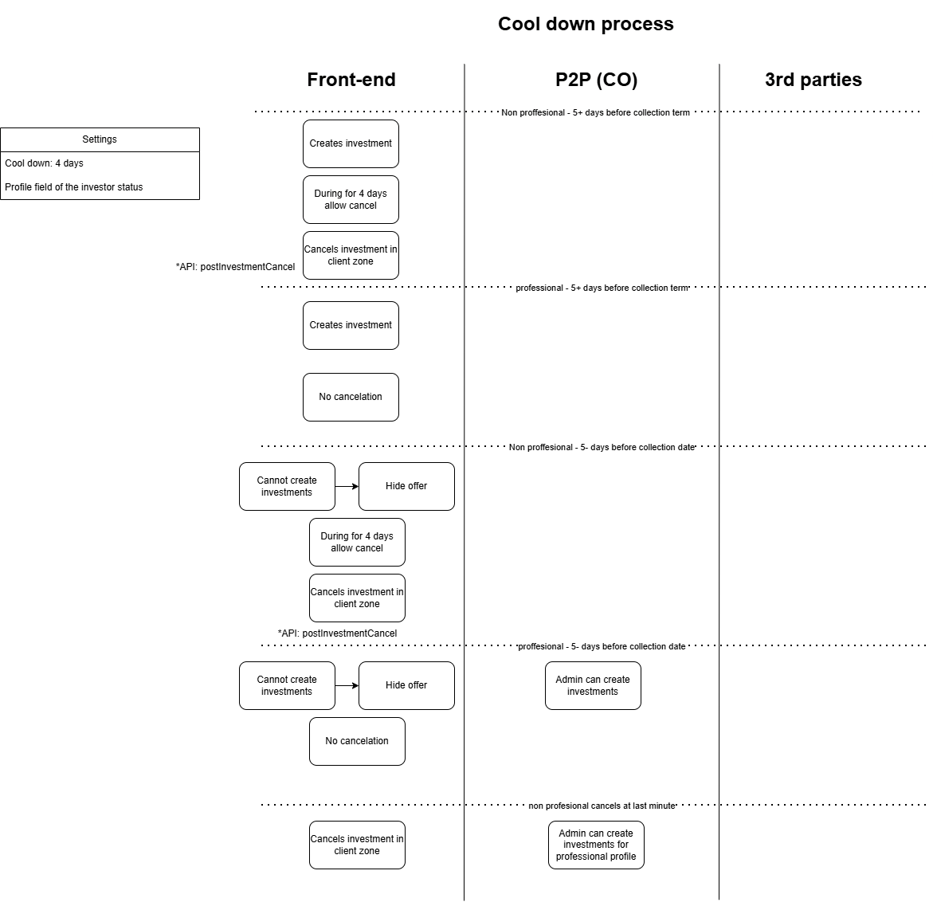
  - Communications logic
    - Templates have been generated on https://mailtrap.io/ on Nerijus account. If modifications or new templates are necessary it might be easiest to access old templates and modify them on mailtrap.io service.
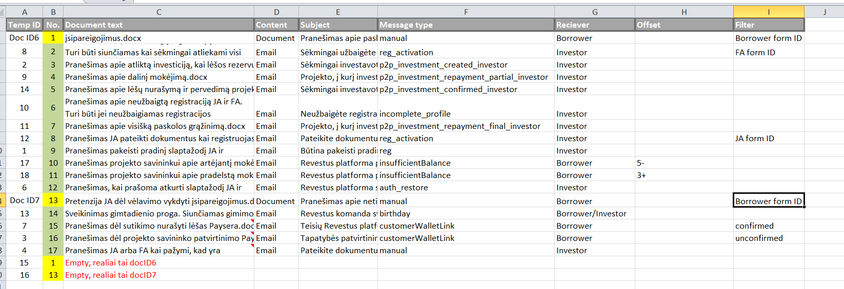
  - Document generation logic
    - System generated documents. There are 7 document templates generated inside the system:
https://revestus-lt.creditonline.eu/admin.php?e=4&edit=775:admin-documents-templates
ID | Template name | Document purpose | Generated by
1 | Investuotojo sutartis - taisykles | Manually created documents | Generated by communication template ID12 and ID8
2 | Klausimynas | Obligations form | Generated by declaration of obligations
3 | Susitarimas prie paskolos sutarties | Documents issued when sending messages/reminders | Generated by com. Template ID14
4 | Grafikas prie paskolos sutarties | Investor documents | Currently not generated.
5 | KYC anketa | Manually created documents | Generated by front-end after filling in questioner
6 | Nutraukimas JA dėl vėlavimo vykdyti įsipareigojimus | Documents issued when sending messages/reminders | Manually generated
7 | Pranešimas apie netinkamai vykdomus įsipareiogjimus pagal paskolos sutartį | Documents issued when sending messages/reminders | Manually generated
    - Front-end hosted documents. There is a set of documents as pdfs that are available to access on front-end:
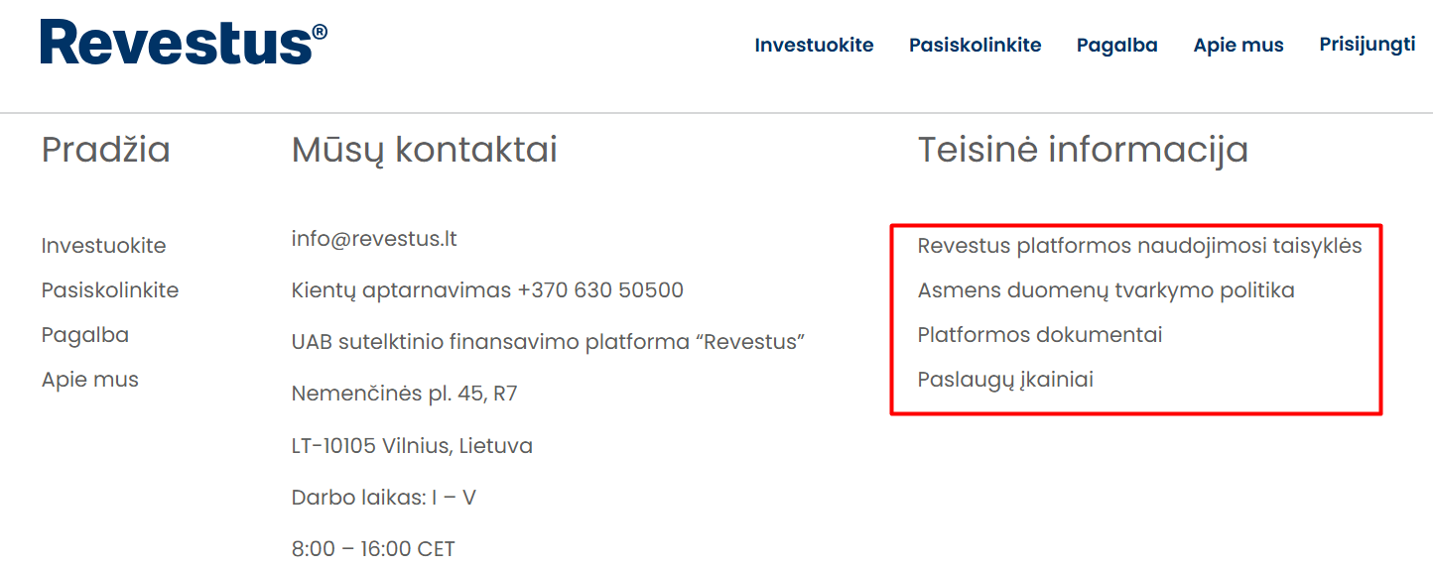
These documents are hosted on front-end side to maintain the front-end domain links. In case of a need to change these documents, that is custom dev work for Tomas.
  - Schedule recalculation particularities. Repayment schedule of loan application that is based on investments (loans balances) originally did not recalculate after collection period resulting in shorter final loan application term:
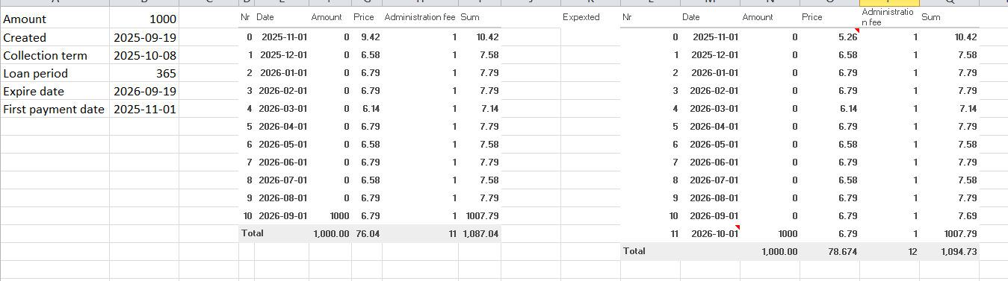
    - A new setting was created that recalculates the investments balances and maintains the initial provided loan application term with expected number of installments.
    - Setting: The adjustment of the installment schedule by days (on application confirmation): fully recreate by issue date.
https://revestus-lt.egroup.eu/admin.php?e=4&edit=700:config
    - It is important for administrator that add new loan application to consider first installment date that is further collection period date and that first payment date match the day then collection term ends.
  - Early repayment particularities
    - If administrator will introduce the early repayment on a loan application, they will also manually add tax1 on loan container:
https://revestus-lt.creditonline.eu/admin.php?e=4&edit=601:LoansContainers&page=1&nid=4
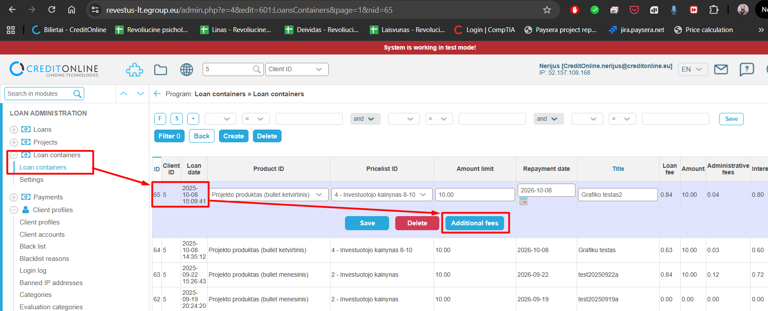
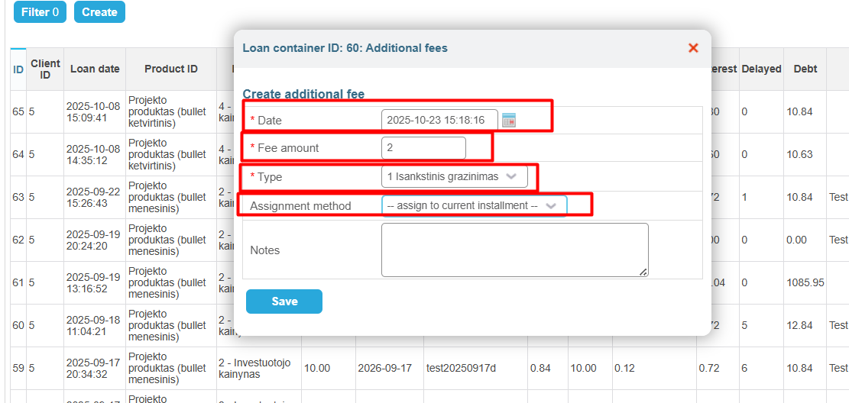
  - Product fees and parameters structure: Quite a few parameters and fees are managed outside of the system, however few fees are also managed manually:
Fee | Beneficiary | Comments/Descriptions
Outside system | For system | Contract setup fee – upfront. 2%–5%, not less than 500 EUR (one-time), paid when transferring funds to the project owner, deducted from the amount paid out to the project owner.
administrative_fee | For system | Monthly (recurring) fee, 0.1% per month from the loan amount, paid monthly together with the installment, goes to Revestus.
interest | For investor | Interest for the project owner – the average is calculated based on the amounts invested by the investors and the interest payable to them. For example, if we collect 1,000 EUR: 500 invested at 8%, 200 at 7%, 300 at 6%, then it should be calculated roughly like this: (5×8 + 2×7 + 3×6) / 10.
late_fee | For investor | Late payment interest (penalty interest) – as we agreed, 0.2% per day, should be calculated from the overdue amount.
cinterest | For investor | Default/compensatory interest – our idea is that, for example, the project owner is charged 10% interest, but if they start delaying payments, during the delay period the interest increases to 20%. When they repay the debt, 10% applies again. Basically, we need to understand how the system itself works — its capabilities to split the collected penalty interest between the investors and us. Then we will decide the best way to implement this.
tax1 | For investor | Early repayment fee – 2%, as discussed, we can also enter it manually.
tax3 only visual | For system | Loan agreement termination fee – 2%, applied when the contract is terminated due to the fault of the project owner.
Outside system | For system | There will also be minor fees. I understand that fees like, for example, a document preparation fee can be handled outside of the system — simply an invoice is issued and the payment is made to a current account. But how about fees that are related to debt recovery? We will need to specify one account for the bailiff. For example, debt recovery fee – 5% from the collected amount. Can this fee be additionally charged to the client and set so that it must be transferred from the transit account to the Revestus account? If yes, then how would payment allocation work in that case — will all these fees need to be added with a defined priority order?
  - Referral bonuses. Flowcharts define a referral type of bonus process that was not confirmed for development by Revestus:
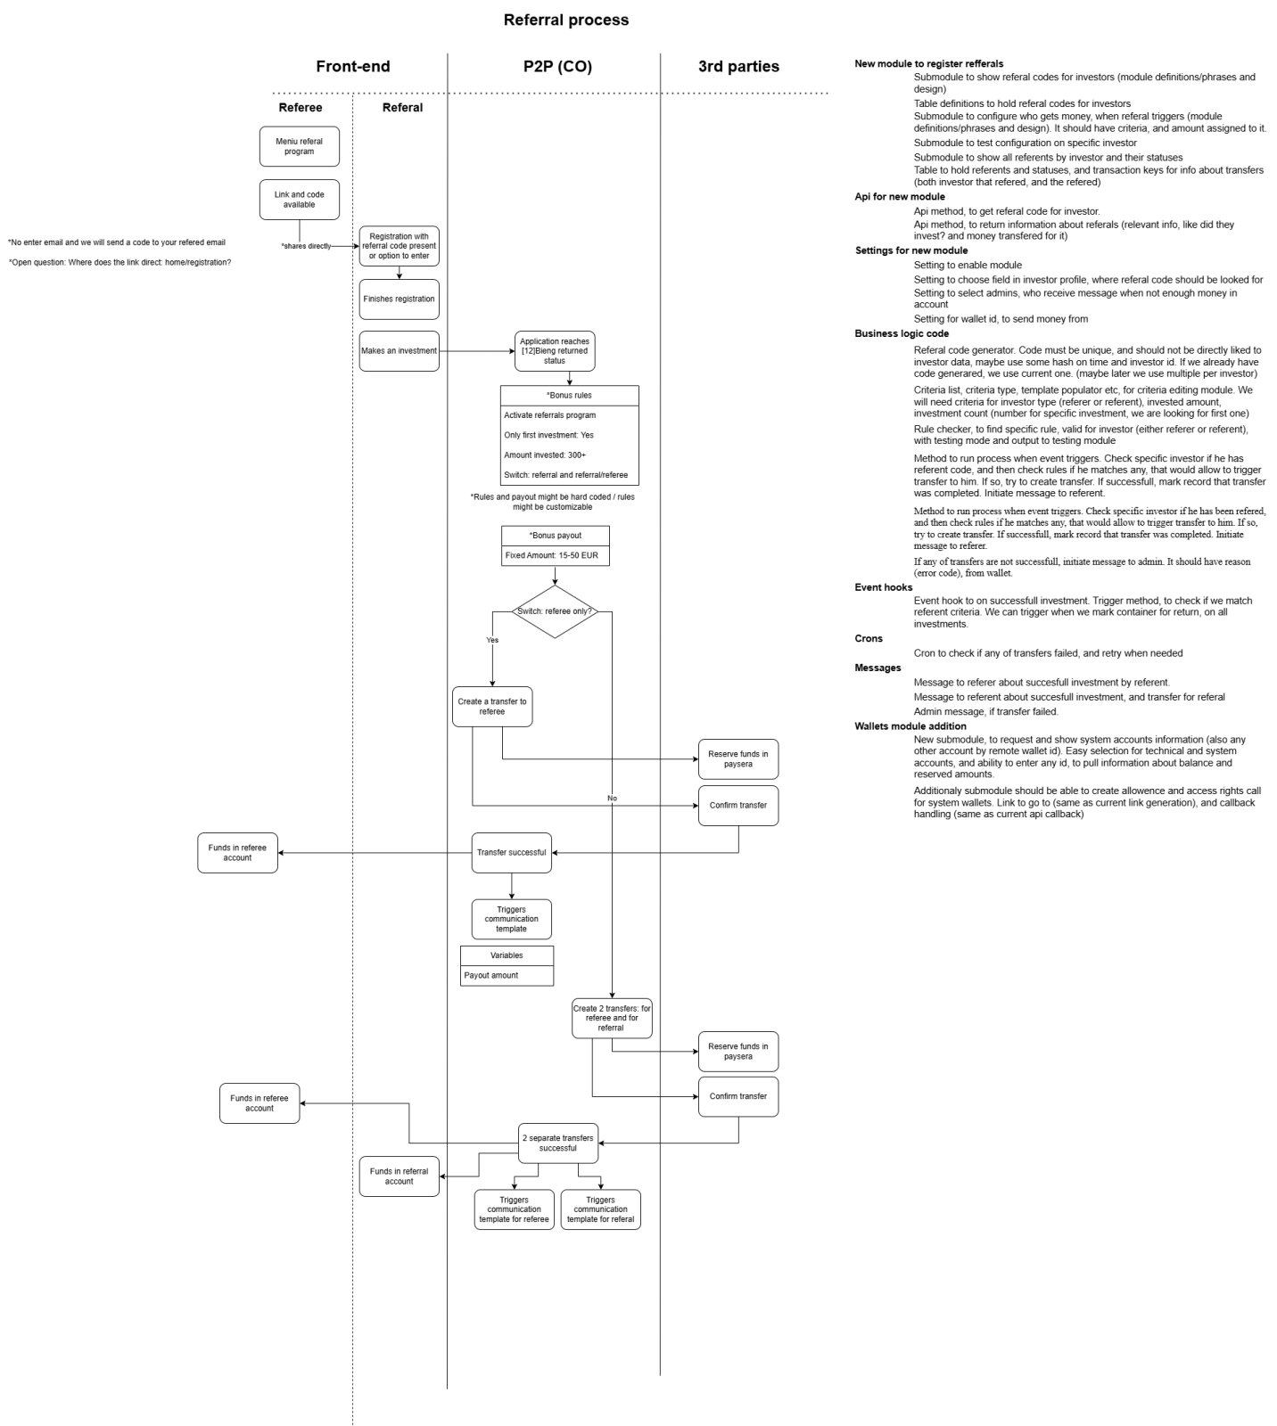The evaluation was done in task: https://www.creditonline.eu/admin.php?e=4&edit=99:tasks&page=0&mode=all&nid=11066
  - Automated investments. The system currently does not have automated investment function, which is in plans to be developed.
- Third party logins – (no test logins available)

